Production Sequence:
Production sequence of textile fabrics – flow chart – brief description. Finishes – classification – Importance of finishes – application methods.
PRODUCTION SEQUENCE OF TEXTILE FABRICS
The sequence normally followed in textile processing is an involved one. Several steps may be repeated. A common sequence is fiber processing followed by yarn processing. Fabrication (producing a fabric) usually follows some preparation steps. In preparation, the yarn or fabric is made ready for additional steps in processing. Bleaching is almost always done before dyeing. Coloration usually is done before finishing and reworking (repairing).Finishing may be done in the mill where the fabric is produced, or it may be done in a separate facility by a highly specialized group called converters.
FLOW CHART
Typical production sequences for textile fabrics
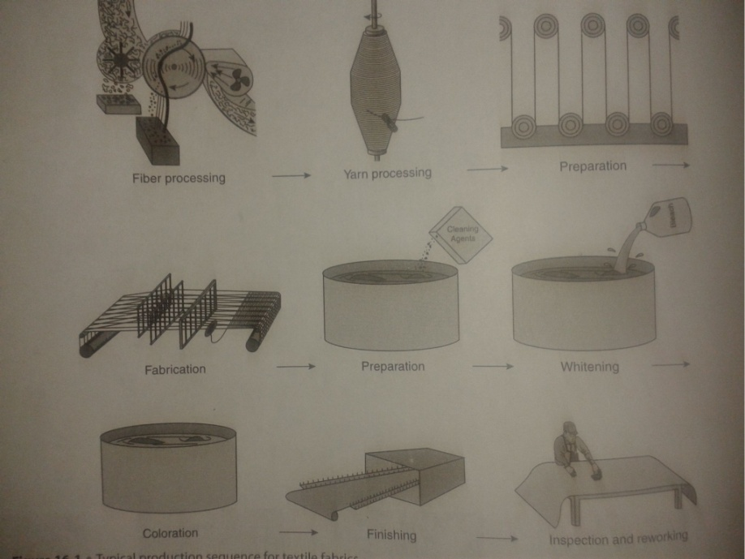

PRODUCTION SEQUENCE OF TEXTILE FABRICS

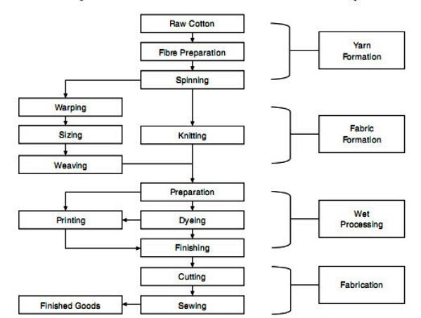

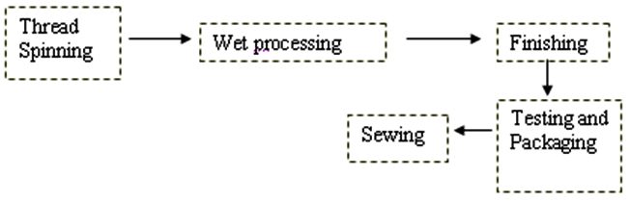

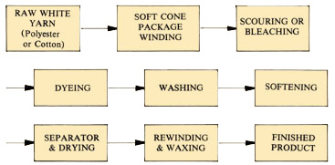

BRIEF DESCRIPTION
FIBER PROCESSING
In fiber processing, the cotton fibers are processed separately from the polyester fibers because of the differences in the properties of the two fiber types. If used in filament from, synthetic fibers such as polyester generally require little additional processing once the fiber has been produced. However, since this fabric is to be a cotton/ polyester blend, staple polyester fibers will be needed for blending. Thus, the polyester fibers were produced as filament tow, crimped and cut or broken into staple fibers, baled and shipped to the yarn-spinning facility.
Since the cotton is a natural fiber, considerably more processing is necessary. The fiber is grown, picked at the appropriate time, ginned, baled and shipped to the yarn processing facility. The cotton’s grade must be assessed because the suitability of the cotton fiber is matched to the end use based on its grade.

YARN PROCESSING
In yarn processing, the fibers are aligned, blended, and twisted. Both cotton fiber bales and polyester fiber bales are opened, and simultaneously dirt and soil are removed. The compact fibers are loosened and aligned in a parallel fashion before the yarns are produced. Several different bales of cotton will be blended to ensure that fabric performance and quality will be consistent from season to season and from year to year. However, since the properties of these two fibers differ significantly, the processing is separate until well into the yarn production process; for blends, fibers are often combined at the drawing or roving stage. Once the fibers are blended, the appropriate amount of twist is added to the yarns. In general, the warp yarns have slightly higher twist to facilitate the weaving process. After the yarns have been spun, they are wound on bobbins and shipped to the mill to be processed into fabric.
YARN PREPARATION
Preparation involves several steps:
SLASHING
In slashing, the warp yarns are treated before being threaded into the loom for weaving. These yarns are usually wound onto a creel and then coated with a mixture of natural starches, synthetic resins (polyvinyl alcohol or polyacrylamide), and other ingredients so that they resist the abrasion and tension of weaving. Slashing adds a protective coating to the yarn to obtain optimal weaving efficiency, increases yarn rigidity, and decreases yarn hairiness.
FABRICATION
Fabrication normally follows slashing. In the fabrication step, the fabric is woven, knitted, or created in some other manner. At the mill, the cotton, polyester yarns are repackaged into the appropriate size unit for weaving. Warp yarns are threaded through the heddles in the harnesses and the spaces in the reed after slashing. Filling yarns are packaged for the specific type of loom to be used in weaving. Since shuttle less looms are common in the U.S textile industry, it is assumed that this fabric will be made on such a loom. The filling yarn length is measured during weaving, and the yarns are cut so that only the length needed for one insertion or pick is available at any time. The filling is inserted in a shed that has every other warp yarn raised to create a plain weave. When the length of warp yarns ahs been woven, the fabric is removed from the loom and the cloth beam is transported to the finishing plant for further finishing.
FINISHES
A finishes is a treatment given to a fabric, to change its appearance handling/ touch or performance. Its purpose is to make the fabric more suitable for its end use.
Finishes can be classified in several ways depending upon their functions, performance
and nature.

Finishing

Finishing is the final step of the Wet processing technology in textiles. It is the general term for a multitude of processes and treatments to add some finishing feathers before marketing, which a fabric may undergo after it has been made (woven or knitted) and colored (dyed or printed).

It is the process carried out on textiles to change the appearance, feel serviceability & durability.

It is the final processing of the cloth and its purpose is to make the fabric suitable for its intended end use. Example: making the fabric shrink proof, softer, stiffer, water repellent, and crease resistant or a combination of these properties.
OBJECTIVES OF FINISHING
- To improve the appearance and make the fabric attractive
- To improve the suitability and utility
- To produce different varieties and desirable qualities to the fabric like Softness, Luster, Drape, Dimensional stability, Crease recovery, Soil repellence and weight.
- To improve appearance and sale appeal for comport and utility.
- To improve the feel of the fabric.
- To cover faults in the original fabric.
- To improve wearing qualities of fabric by making it shrink or crease resistant and set garment shape. E.g. Durable press.
- To import special properties to the fabric for special end uses such as waterproofing, flame-proofing etc.
- To strengthen the fabric by coating or laminating.
- To produce novelty effects e.g. organdie fabrics by parchment sing.
CLASSIFICATION OF FINISHES
Textile finishes and finishing are classified in several ways. There are explained as follows:-
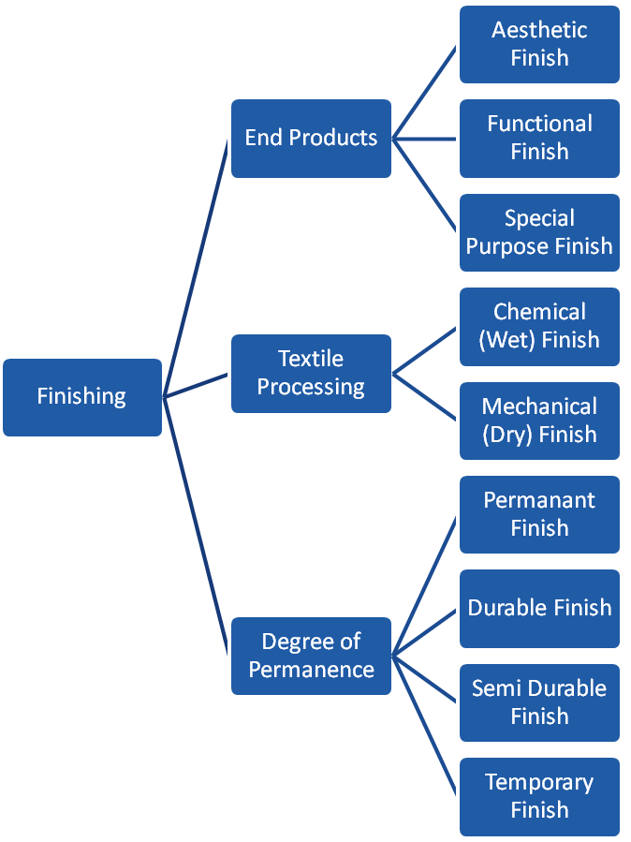
- Persons concerned with end products (designers, merchandisers and sales personnel) usually categorize finishes as Aesthetic Finish, Functional Finish and Special Purpose Finish for modify the appearance and/or hand (feel) of fabrics, while the latter improve the performance of a fabric under specific end use conditions.
- Persons concerned with textile processing (chemists and finishers) categorize finishes into chemical finishes and mechanical finishes. These are also called wet finishing and dry finishing.
- Finishes are also categorized by their degree of permanence. These finishes are called permanent, durable, semi-durable and temporary.
- Permanent finishes usually involve a chemical change in fibre structure and will not change or alter throughout the life of a fabric.
- Durable finishes usually last throughout the life of the article, but effectiveness becomes diminished after each cleaning and near the end of the normal use life of the article, the finish is nearly removed.
- Semi-durable finishes last through several launderings or dry cleanings and many are renewable in home laundering or dry cleaning.
- Temporary finishes are removed or substantially diminished the first time an article is laundered or dry cleaned.
IMPORTANCE OF FINISHING
- Crease resistance properties are improved.
- Handle & Draping qualities are improved.
- Weight & Dimensional stabilities are improved.
- Crease recovery properties are improved.
- Color fastness properties are improved.
- Shrinkage will be reduced while laundering.
- The fabrics may be dried quickly.
- The fabric strength will be increased.
- Light & Laundry resistance have given good results.
- Improve the appearance of fabric and enhance its looks
- Produce variety in fabrics through dyeing and printing
- Improve the feel or touch of fabric
- Make the fabric more useful
- Improve the draping ability of light weight fabrics
- Make fabric suitable for an end (specific) use

ON THE BASIS OF FUNCTION

The finishes may be basic or functional basic or common finishes are applied to almost all the fabrics, with an aim to improve their appearance, feel and body. Pale white cotton fabrics may be bleached to improve their whiteness. For better look of a thin cotton fabric, starch is applied to increase its weight and shine. Steam Ironing, Calendaring (industrial ironing) is a basic finish. These are also known as aesthetic finishes.
Dyeing and printing are also considered as finishes as they enhance the aesthetic appearance of fabrics.

FUNCTIONAL or special finishes are applied to improve the performance of a fabric
for some specific purpose, for example
- Fireproof finish prevents the burning of fabrics used by fire brigade personnel
- Waterproof finish makes fabrics water repellent for making umbrellas and
raincoats
- Bullet-proof finish on fabric saves the people from bullets and is generally used
by defence and police personnel for their safety, and
- Crease-resistant finish makes cotton / wool fabric wrinkle resistant.

ON THE BASIS OF DEGREE OF PERFORMANCE
On the basis of performance, finishes are temporary, semi durable, durable and permanent.
TEMPORARY finishes are not durable and run off after first washing or dry-cleaning.
Many of these are renewable and can be reapplied at home, e.g. starching and blueing of white fabrics.

SEMI DURABLE finishes stay on the fabric surface for several washings, e.g. bleaching and certain dyes used on cotton.

DURABLE finishes last through out the life of a fabric or a garment but may lose its effectiveness after many washes, e.g. permanent pleats, wrinkle resistant, etc.

PERMANENT finishes are is usually given by a chemical treatment. It changes the fibre structure and remains as such on the fabric for the entire life of a fabric, e.g.
waterproofing, fire proofing, etc.

CHEMICAL AND MECHANICAL FINISHES / WET AND DRY FINISHES
On the basis of processes involved in application of finish, there are two types – chemical
(wet) and mechanical (dry) finishes.

CHEMICAL FINISHES: These are also known as wet finishes. In these, chemical treatment is given to fabric, either to change its appearance or basic properties. These finishes are usually durable and permanent or wet finishes. Examples are: fire proof, crease resistance, etc.

MECHANICAL FINISHES: These are also known as dry finishes. Here the process consists of application of moisture, pressure and heat or a mechanical device to finish a fabric. Beating, brushing, calendaring, filling, etc. are some of the finishes included in this group. These finishes are either temporary or semi durable and do not last long.

APPLICATION METHODS

FINISHING PROCESSES
The finishing processes that are available can be divided into four main groups,
which are:

MECHANICAL PROCESSES:
These involve the passage of the material through machines whose mechanical action achieves the desired effects. A heating process, the purpose of which is usually to enhance these desired effects, frequently accompanies this. These mechanical finishes, which will be discussed in detail later in this section are

CALENDERING: compression of the fabric between two heavy rolls to give a flattened,
smooth appearance to the surface of the fabric.

RAISING: plucking the fibres from a woven or knitted fabric to give a nap effect on the surface.
CROPPING: cutting the surface hairs from the a fabric to give a smooth appearance, often used on woollen goods where the removal of surface hair by a singeing process is not possible.
COMPRESSIVE SHRINKAGE: the mechanical shrinking of the warp fibres in woven fabrics so that shrinkage on washing is reduced to the desired level.

HEAT SETTING: this is a process for the stabilisation of synthetic fibres so that they do not shrink on heating.

CHEMICAL PROCESSES: These may be described as those processes that involve the application of chemicals to the fabric. The chemicals may perform various functions such as water repellency or flame retardancy, or may be used to modify the handle of a fabric. Chemical finishes are normally applied in the form of an aqueous solution or emulsion and may be applied via a variety of techniques, the main one being the pad mangle, After the padding or the application stage of the chemical finishing the fabric is usually dried to remove the water from the fabric and some form of fixation of the finish is then performed. This commonly takes the form of a baking process, where the fabric is subjected to a high temperature for a short period, which enables the applied chemicals to form a more durable finish on the fabric than would otherwise be achieved.

