UNIT - II
Manufacturing process, properties and uses of, Man-made fibers –viscose rayon, acetate rayon, nylon, polyester, and acrylic.

AIM AND OBJECTIVES

- Properties and Uses of Manmade fibres.
- Different types of manmade fibre.
- Manufacturing process of manmade fibres.

INTRODUCTION

MAN-MADE FIBER
There are two main categories of man-made fibers: those that are made from natural products (cellulosic fibers) and those that are synthesized solely from chemical compounds (non cellulosic polymer fibers). Rayon is a natural-based material that is made from the cellulose of wood pulp or cotton. This natural base gives it many of the characteristics low cost, diversity, and comfort thathave led to its popularity and success. Today, rayon is considered to be one of the most versatile and economical man-made fibers available.

VISCOSE RAYON
The process of manufacturing viscose rayon consists of the following steps mentioned, in the order that they are carried out: 1. Cellulose, 2. Steeping, 3.Pressing, 4. Shredding, 5. Aging, 6.Xanthation, 7. Dissolving, 8. Ripening, 9.Filtering, 10. Degassing, 11. Spinning, 12. Drawing, 13. Washing, 14. Cutting.
The various steps involved in the process of manufacturing viscose are shown in

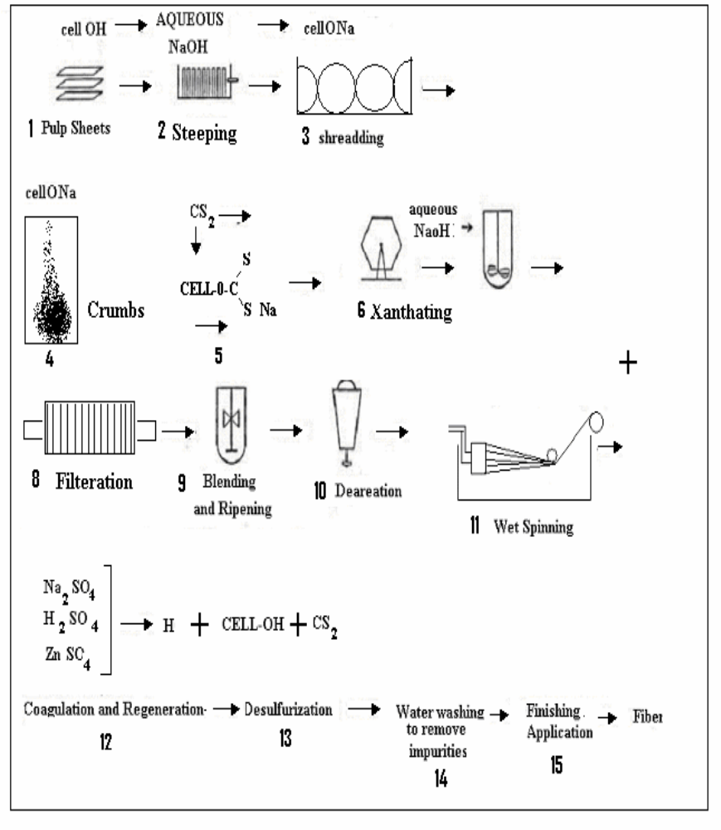
1. Cellulose
Purified cellulose for rayon production usually comes from specially processed wood pulp. It is sometimes referred to as dissolving cellulose or dissolving pulp to distinguish it from lower grade pulps used for papermaking and other purposes. Dissolving cellulose is characterized by a high a -cellulose content, i.e., it is composed of long-chain molecules, relatively free from lignin and hemicelluloses, or other short-chain carbohydrates.
2. Steeping
The cellulose sheets are saturated with a solution of caustic soda (or sodium hydroxide) and allowed to steep for enough time for the caustic solution to penetrate the cellulose and convert some of it into soda cellulose, the sodium salt of cellulose. This is necessary to facilitate controlled oxidation of the cellulose chains and the ensuing reaction to form cellulose xanthate.
3. Pressing
The soda cellulose is squeezed mechanically to remove excess caustic soda solution.
4. Shredding
The soda cellulose is mechanically shredded to increase surface area and make the cellulose easier to process. This shredded cellulose is often referred to as white crumb.
5. Aging
The white crumb is allowed to stand in contact with the oxygen of the ambient air. Because of the high alkalinity of white crumb, the cellulose is partially oxidized and degraded to lower molecular weights. This degradation must becare fully controlled to produce chain lengths short enough to give manageable viscosities in the spinning solution, but still long enough to impart good physical properties to the fiber product.
6. Xanthation
The properly aged white crumb is placed into a churn, or other mixing vessel, and treated with gaseous carbon disulfide. The soda cellulose reacts with theCS2 to form xanthate ester groups. The carbon disulfide also reacts with the alkaline medium to form inorganic impurities which give the cellulose mixture a characteristic yellow color and this material is referred to as yellow crumb. Because accessibility to the CS2 is greatly restricted in the crystalline regions of the soda cellulose, the yellow crumb is essentially a block copolymer of cellulose and cellulose xanthate.
7. Dissolving
The yellow crumb is dissolved in aqueous caustic solution. The large xanthate substituents on the cellulose force the chains apart, reducing the inter chain hydrogen bonds and allowing water molecules to solvate and separate the chains, leading to solution of the otherwise insoluble cellulose. Because of the blocks of un-xanthated cellulose in the crystalline regions, the yellow crumb is not completely soluble at this stage. Because the cellulose xanthate solution (or
More accurately, suspension) has a very high viscosity, it has been termed viscose.
8. Ripening
The viscose is allowed to stand for a period of time to ripen. Two important processes occur during ripening: Redistribution and loss of xanthate groups. The reversible xanthation reaction allows some of the xanthate groups to revertto cellulosic hydroxyls and free CS2. This free CS2 can then escape or react with other hydroxyl on other portions of the cellulose chain. In this way, the ordered, or crystalline, regions are gradually broken down and more complete solution is achieved. The CS2 that is lost reduces the solubility of the cellulose and facilitates regeneration of the cellulose after it is formed into a filament.
9. Filtering
The viscose is filtered to remove un dissolved materials that might disrupt the spinning process or cause defects in the rayon filament.
10. Degassing
Bubbles of air entrapped in the viscose must be removed prior to extrusion or they would cause voids, or weak spots, in the fine rayon filaments.
11. Spinning - (Wet Spinning)
The viscose is forced through a spinneret, a device resembling a shower head with many small holes. Each hole produces a fine filament of viscose. As the viscose exits the spinneret, it comes in contact with a solution of sulfuric acid, sodium sulfate and, usually, Zn++ ions. Several processes occur at this point which cause the cellulose to be regenerated and precipitate from solution. Water diffuses out from the extruded viscose to increase the concentration in the
filament beyond the limit of solubility. The xanthate groups form complexes with the Zn++ which draw the cellulose chains together. The acidic spin bath converts the xanthate functions into unstable xantheic acid groups, which spontaneouslylose CS2 and regenerate the free hydroxyls of cellulose. (This is similar to the well-known reaction of carbonate salts with acid to form unstable carbonic acid, which loses CO2). The result is the formation of fine filaments of cellulose, or rayon.
12. Drawing
The rayon filaments are stretched while the cellulose chains are still relatively mobile. This causes the chains to stretch out and orient along the fiber axis. As the chains become more parallel, inter chain hydrogen bonds form, giving the filaments the properties necessary for use as textile fibers.
13. Washing
The freshly regenerated rayon contains many salts and other water soluble impurities which need to be removed. Several different washing techniques maybe used.
14. Cutting
If the rayon is to be used as staple (i.e., discreet lengths of fiber), the group of filaments (termed tow) is passed through a rotary cutter to provide a fiber which can be processed in much the same way as cotton.

Physical and Chemical Properties of Rayon
1. Strength
The tensile strength of viscose rayon is greater than that of wool, but is only about half as great as that of silk. Viscose rayon is also weaker than cotton and linen and its strength is reduced 40 to 70% when wet. The strength is controlled by stretching, which causes a greater orientation of the molecules. Viscose is easily stretched when wet and swollen. If dried in a stretched condition, it will relax and shrink upon again becoming wet.
2. Elasticity
Viscose rayon has greater elasticity than cotton or linen but less than wool or silk.
3. Drapability
Viscose rayon possesses a marked quality of Drapability because it is are latively heavyweight fabric. The filament can be made as coarse as desired depending on the holes in the spinneret.
4. Resilience
Viscose rayon lacks the resilience natural to wool and silk and creases readily; but it should be remembered that the resistance of a fabric to creasing depends on the kind of yarn, weave, and finishing process.
5. Heat Conductivity
Viscose rayon is a good conductor of heat and is therefore appropriate for summer clothing. Spun rayon fabrics, however, are adaptable to winter apparel because they can be napped.
6. Absorbency
Viscose rayon is a one of the most absorbent of all textiles. It is more absorbent than cotton or linen. The combination of high heat conductivity and high absorbency of rayon makes it very suitable for summer wear.
7. Cleaning and Wash ability
Because of its smoothness, viscose, rayon fibre helps to produce hygienic fabric that shed dirt. Some viscose rayon fabrics wash easily, and depending on the finish that may be given to them, they will not become yellow when washed or dry cleaned. Regular rayon fabrics have limited wash ability because of the low strength of the fibre when wet. When laundered, a mild soap or
detergent and warm water should be used.
8. Shrinkage
Viscose rayon fabrics tend to shrink more than cotton fabrics of similar construction. Knitted fabric always shrinks more than flat woven fabrics because of the nature of the construction. When spun viscose rayon is blended with wool, the great amount of shrinkage characteristic of the wool is reduced.
9. Affect of Heat
Since viscose rayon is a pure cellulose fibre, it will burn in much the same manner as cotton. Application of heat at 300°F (150°C) causes viscose rayon to lose strength; above 350°F (177°C), it begins to decompose.
10. Effect of Light
Viscose rayon has generally good resistance to sunlight, though prolonged exposure of intermediate tenacity rayon results in faster deterioration and yellowing.
11. Resistance to Mildew
Like cotton, viscose rayon has a tendency to mildew. Moths are not attracted to cellulose. Consequently, moth-proffering treatments are not necessary for viscose rayon. Resistance to other insects is also similar to that of cotton.
12. Reaction to Alkalies
Viscose rayon is fairly resistant to alkalies and oxidizing agents but tends to be harmed to a greater extent by alkalies than are cotton or linen. A mild soap and warm water is recommended when laundering such garments.
13. Reaction to Acids
Viscose rayon reacts to acids in a manner similar to cotton. It is harmed by acids. Being pure cellulose, the fabric is disintegrated by hot dilute and cold concentrated acids.
14. Affinity for Dyes
Viscose rayon has good affinity for most cotton dyes. Viscose rayon fabrics absorb dyes evenly and can be dyed with a variety of dyes, such as direct, acid, chrome and disperse. Colored viscose rayon have a high resistance to sunlight. This property makes them suitable for window curtains.
15. Resistance to Perspiration
Viscose rayon is fairly resistant to deterioration from perspiration. The colour,
however, is not usually as resistant as the fabric and will fade if not solution-dyed.
Major Rayon Fiber Uses
• Apparel: Accessories, blouses, dresses, jackets, lingerie, linings, millinery,
slacks, sport shirts, sportswear, suits, ties, work clothes
• Home Furnishings: Bedspreads, blankets, curtains, draperies, sheets,
slipcovers, tablecloths, upholstery
• Industrial Uses: Industrial products, medical surgical products, nonwoven
products, tire cord
• Other Uses: Feminine hygiene products

ACETATE RAYON

• Cellulose + Glacial Acetic Acid + Acetic Anhydride + Sulphuric acid (Cotton linter, wood pulp)

• Frimary Cellulose Acetate + Water

• (Cellulose tri-acetate)

• Secondary Cellulose Acetate + Acetone

• Acetate Spinning Solution .

• Dry Spinning in Warm Air Acetate Filament

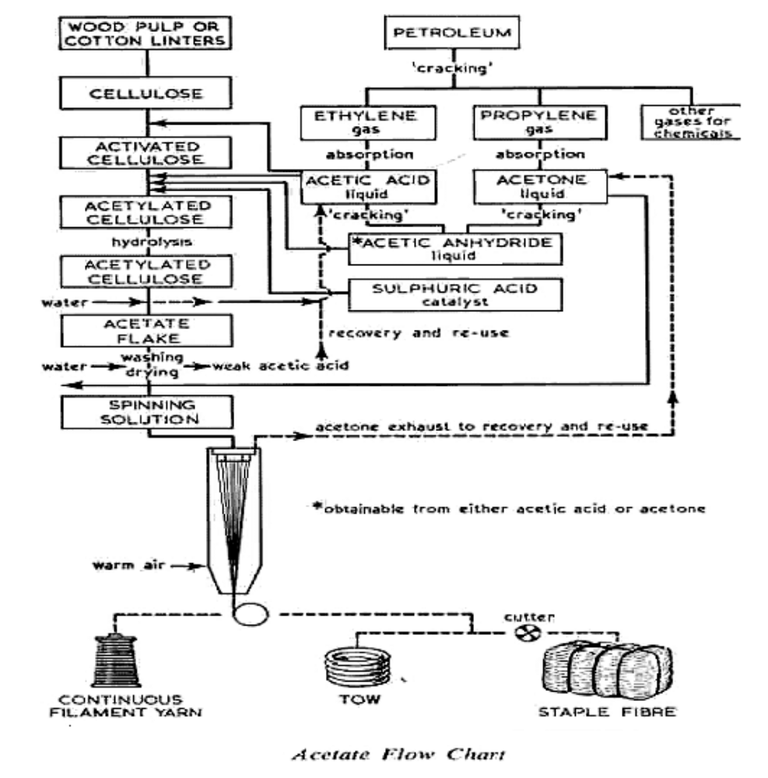

Cotton linters or wood chips are converted into sheets of pure cellulose. The cellulose is steeped in glacial acetic acid and aged for a period of time under a controlled temperature. After aging, it is thoroughly mixed with acetic an hydride. A small amount of sulphuric acid is then added as a catalyst to facilitate are action producing a thick, clear liquid solution of cellulose acetate. After further aging, water is added, and causing the cellulose acetate to precipitate as white flasks. The flasks are dried, dissolved in acetone, and filtered several times to remove impurities. The result is clear, white spinning solution of the consistency of syrup.
If delustered yarn is required, titanium dioxide, a delusterant, is added at this stage to produce the desired degree of brightness: bright, semi dull, or dull. Dyestuff may be added to the spinning solution to provide superior colour fastness. After the delusterant has been added, the spinning solution is forced through a spinneret and into a cabinet of heated air that evaporates the acetone
and solidifies the filament. The filaments are then ready for winding on spools, cones, or bobbins ready for shipping to the mills for weaving or knitting. Staple fibres are cut, crimped, lubricated, dried, and baled for shipment.
Physical and Chemical Properties of Acetate
The properties of acetate fabrics will vary to some extent depending on the type of yam used (filament, textured, or spun), on the type of fabric construction, and on the finish.
1. Strength
Acetate is not a strong fibre. It is weaker than any rayon and is, in fact, one of the weakest textile fibres. It loses much of its strength when wet.
2. Elasticity
Acetate is more elastic than any rayon.
3. Resilience
Acetate is more wrinkle resistant than any rayon; consequently, the fabric will tend to return to its original shape much better than will rayon after it is pulled or crumpled. After washing, acetate garments should be carefully hung to permit the yams to relax to their original shape.
4. Durability
Acetate fabrics have good body and flexibility and therefore drape very nicely.
5. Heat Conductivity
Acetate does not have as high a rate of heat conductivity as rayon and therefore is warmer. Acetate is consequently more useful for linings and warmer clothing, particularly if it is spun acetate.
6. Absorbency
Acetate is not very absorbent. It absorbs only half as much moisture as the rayon’s. Acetate fabric gets wet mostly on the surface and will not become saturated; therefore; they dry quickly. This makes acetate very suitable for shower curtains, umbrellas, and rain coats. It is also suited for bathing suits, particularly at the seashore because salt water does not have any deteriorating effect on acetate. On the other hand, acetate is uncomfortable in warm, humid weather because of its low absorbency. Acetate garments, such as blouses and lingerie, worn next to the skin feel clammy and uncomfortable because they do not absorb atmospheric humidity.
7. Cleanliness and Wash ability
Acetate fibre smoothness helps to produce hygienic fabrics that shed dirt and wash easily. They will not become yellow when washed or dry cleaned. Since acetate temporarily loses some strength when wet such fabrics must be handled with care when washed. When laundered, a mild soap or detergent and warm water should be used. The garments should not be rubbed rigorously but should be handled gently and squeezed to remove the water. They will dry readily and should be hung so that the water will drip off. Acetate garments dry clean well.
8. Effect of Bleaches
White acetate remains white, and acetate fabrics need not be bleached. If bleaching is desired, it should be done with a very mild solution of hydrogen peroxide or a very dilute solution of sodium hypochlorite.
9. Shrinkage
Acetate fabrics will shrink less than any rayon. Sometimes they are given a shrink resistant finish.
10. Effect of Heat
Acetate fabrics need less ironing than rayon fabrics. A warm iron will easily smooth out an acetate fabric, particularly if the fabric is a little damp. If the form is too hot, it will melt the acetate causing it to stick to the iron and make the fabric stiff.
11. Effect of Light
Acetate is more resistant to the effect of light than cotton or any rayon. Over a period of time, acetate will be weakened from exposure to light.
12. Resistance to Mildew
Acetate is highly resistant to mildew. It is ideal for fabrics exposed to moisture, such as shower curtains.
13. Reaction to Alkalies
Strong alkalies should not be used on acetate since they cause a chemical change in the fibre.
14. Reaction to Acids
Acetate is more resistant to acids than pure cellulose, but it will be decomposed by concentrated solutions of strong acids.
15. Resistance to Perspiration
Acetate fabrics are fairly resistant to deterioration by perspiration, but the colour will be affected if it has not been solution-dyed.
NYLON
The first truly synthetic fibre was nylon, which originated from research work in the United States and represented a radically different chemical structure and potentially new properties for textiles. Nylon is a general name, which covers materials with a range of qualities, including the two most important clothing types, nylon 6 and nylon 66. All nylon is made from products derived from coal tar or oil and possesses some very unusual properties, including high strength
and luster. Certain nylons may be textured and bulked to produce particular tactile qualities in cloth. Other fibres discovered more recently (1941) include the class known as polyester. This largely British invention has, in its Terylene form, many similarities to nylon. Acrylic fibre, produced alongside polyester after1950, represented the first realistic wool substitute. Its warmth has led it to be used widely for knitwear.
Other fibres among the true synthetics include modacrylics and elastomers. The latter are currently extremely popular as Lycra, its stretch properties be ingutilized in sports clothing.

Any synthetic plastic material composed of polyamides of high molecular weight and usually, but not always, manufactured as a fibre. Nylons were developed by Du Pont in the 1930s. The successful production of a useful fibre by chemical synthesis from compounds readily available from air, water, and coal or petroleum stimulated expansion of research on polymers, leading to a rapidly growing family of synthetics.
Basic Concepts of Nylon Production

The first approach: combining molecules with an acid (COOH) group on each end are reacted with two chemicals that contain amine (NH2) groups on each end.
This process creates nylon 6, 6, made of hexamethylene diamine with six carbonatoms and acidipic acid, as well as six carbon atoms.
• The second approach: a compound has an acid at one end and an amine at the other and is polymerized to for a chain with repeating units of(-NH-[CH2]n-CO-)x.
o In other words, nylon 6 is made from a single six-carbon substance called caprolactam.
o In this equation, if n=5, then nylon 6 is the assigned name. (May also be referred to as polymer)

Manufacturing of Nylon
• Carbon + Nitrogen + Hydrogen + Oxygen(coal) (air) (water) (air)+

• Adipic Acid and Hexamethylene Diamine

• Amide (Nylon Salt)

• Heated in Vaccum (Loss of Water)

• Nylon Super Polymer

􀂙 Heated

• Nylon Spinning Solution (Polyamide)

􀂙 Dry Spinning (Cool Air)

􀂙 Drawing and Stretching

• Nylon Filament

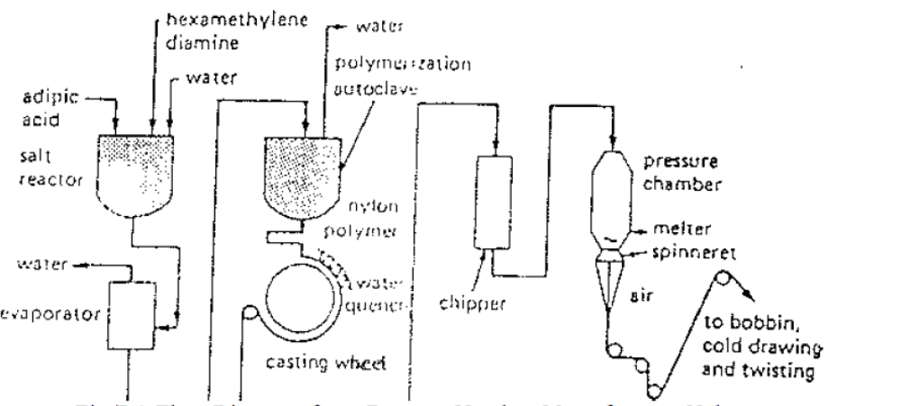
Fig 7.1 Flow Diagram for a Process Used to Manufacture Nylon

Nylon is actually a group of related chemical compounds. It is composed of hydrogen, nitrogen, oxygen and carbon in controlled proportions and structural arrangement. Variations can result in types of nylon plastics, such as combs, brushes, and gears.
By a series of chemical steps beginning with such raw materials as coal, petroleum, or such cereal byproducts as oat hulls or corncobs, two chemicals called hexamethylene diamine and adipic acid are made. These are combined to form nylon salt. Then, since the nylon salt is to be shipped to the spinning mill, it is dissolved in water for easily handling. At the spinning mill, it is heated in large evaporators until a concentrated solution is obtained. The concentrated nylon salt solution is then transferred to an autoclave, which is like a pressure cooker. The heat combines the molecules of the two chemicals into giant chainlike ones, called linear super polymers. The linear super polymer is then allowed to flow out of a slot in the autoclave onto a slowly revolving casting wheel. As the ribbons of molten nylon resin are deposited on the wheel, they are sprayed with cold water, which hardens them to milky white opaque ribbons. The ribbons are removed from the casting wheel to a chipper, which transforms them into flakes.
Nylon flakes are blended and poured into the hopper of the spinning machine to insure uniformity in the final nylon yarn. Through a value in the bottom of the hopper, the nylon flakes fall onto a hot grid, which melt, them? The molten nylon is pumped through a send filter to the spinneret. The spinneret has one or more holes, depending on the purpose for which the yarn is to be made. As the filaments come out of the spinneret and hit the air, they solidify. This filament can be changed, however, by stretching or cold drawing, the filaments from two
to seven times their original length. The amount of stretching is dependent on the diameter, elasticity, and strength desired. As the filaments are stretched, they become more and more transparent. The polyamide molecules straighten out, become parallelized, and are brought very close together. Up to a point, the nylon becomes stronger, more elastic, more flexible and more pliable.

Physical and Chemical Properties of Nylon
1. Strength
Nylon is produced in both regular and high tenacity strengths. Although one of the lightest textile fibre, it is also one of the strongest. The strength of nylon will not deteriorate with age.
2. Elasticity
Nylon is one of the most elastic fibres that exists today, though it does not have the exceptional elastic quality of spandex fibre. After being stretched, nylon has a strong natural tendency to return to its original shape, and has its own limit to elasticity. If stretched too much, it will not completely recover its shape. Spun nylon is not as elastic as filament nylon.
3. Resilience
Nylon has excellent resilience. Nylon fabrics retain their smooth appearance, and wrinkles from the usual daily activities fall out readily.
4. Shrinkage
Nylon has good dimensional stability and retains its shape after being wet.
5. Drapability
Fabrics at nylon yarn have excellent draping qualities. Lightweight sheers may have a flowing quality, medium-weight dress fabrics can drape very nicely, and heavier weight jacquards also drape well.
6. Heat Conductivity
Nylon fabrics may or may not conduct heat well. The warmth or coolness of a nylon garment depends on the weave of the fabric and on the type of yarn used. The smoothness, roundness, and fineness of nylon filaments permit the manufacture of very smooth, very fine yarns, which can be packed very closely when weaving the fabric. If nylon fabric is woven compactly, it will not be porous. The tight construction will not permit air to circulate through the fabric, and the heat and moisture of the body will not readily pass through it but will built up between the fabric and the body: so, the wearer will feel very warm.

7. Absorbency
Nylon does not absorb much moisture. Fabrics made of nylon filament yarns will not readily wet through the material-most of the water remains on the surface and runs off the smooth fabric, which therefore dries quickly. Such fabrics are useful for rain coats and shower curtains. Spun nylon fabrics, however, will not dry quickly. Nylon's low absorbency has a disadvantage in
that the fabric feels clammy and uncomfortable in warm, humid weather.
8. Cleanliness and Washability
Because of nylon's smooth surface, dirt and stains often come clean merely using a damp cloth. To wash nylon garments by hand or washing machine, use lukewarm water at 100°F (38°C) and a detergent or soap with a water softener. Nylon filament fabrics dry very quickly. They need little or no ironing because the garments are usually heat set to retain their shape, pleats or creases. Spun nylon has a tendency to pill or form balls, on the surface of the fabric. To
minimize thus, such fabrics should not be rubbed. They should be washed gently, preferably by hand. Brushing with a soft brush will reduce the pilling.
9. Effect of Heat
Like acetate, nylon will melt if the iron is too hot, therefore, the iron should be set at the proper heat level. It does not burn readily but melts to form glossy beads formation.
10. Effect of Light
Bright nylon is more resistant to the effects of sunlight than most other fibres. Dull nylon will deteriorate a little more quickly than bright nylon; however, even dull nylon has good resistance to light.
11. Resistance to Mildew and Insects
Mildew has absolutely no effect on nylon. Mildew may form on nylon, but it will not weaken the fabric. Moths and other insets will not attack nylon because it has no attraction for them.
12. Reaction to Alkalies
Nylon is substantially inert to alkalies. No reaction with soap, alkalis and alcohols.
13. Reaction to Acids
Nylon is decomposed by cold concentrated solutions of such mineral acids as hydrochloric, sulphuric and nitric acids. A boiling dilute 5% solution of hydrochloric will destroy nylon
Major End Uses
• Apparel - swimwear, active wear, intimate apparel, foundation garments, hosiery, blouses, dresses, sportswear, pants, jackets, skirts, raincoats, ski and snow apparel, windbreakers, children’s wear.
• Home Fashions - carpets, rugs, curtains, upholstery, draperies, bedspreads
• Other - Luggage, back packets, life vests, umbrellas, sleeping bags, tents.
Properties
• Lightweight
• Exceptional strength
• Good drape ability
• Abrasion resistant
• Easy to wash
• Resists shrinkage and wrinkling
• Resilient, pleat retentive
• Fast drying, low moisture absorbency

POLYSTER
Polyester is a synthetic fiber derived from coal, air, water, and petroleum. Developed in a 20th-century laboratory, polyester fibers are formed from a chemical reaction between an acid and alcohol. In this reaction, two or more molecules combine to make a large molecule whose structure repeats throughout its length. Polyester fibers can form very long molecules that are very stable and strong.

Manufacturing of Polyester
• Terephthalic Acid + Ethylene Glycol
o Polymerization
• Polyester + Highly Heated
• Polyester Spinning Solution
o Melt or Dry Spinning (Cool Air)
• Filament
o Drawing and Stretching
• Polyester Filament
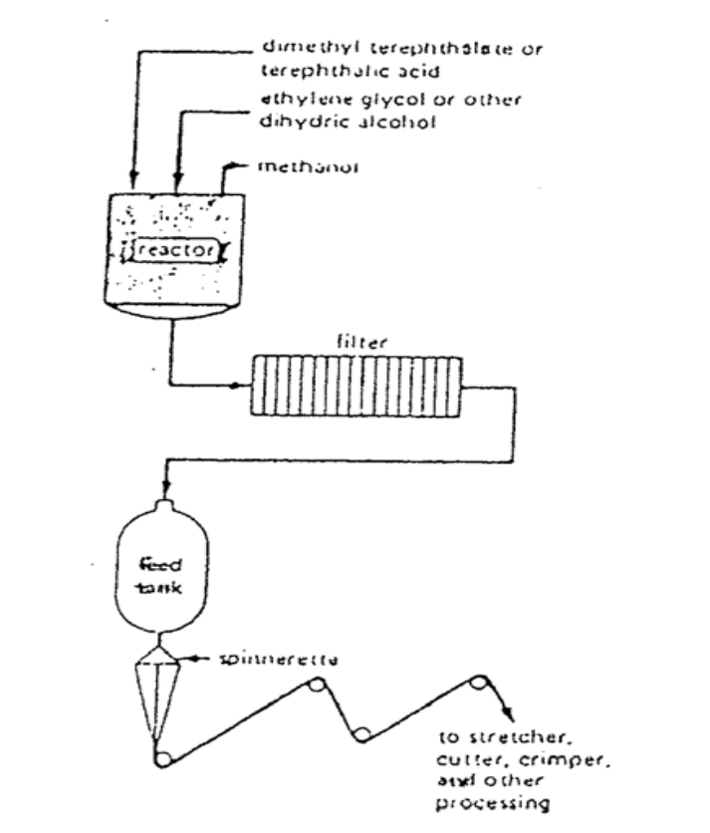

1. Polymerization
• To form polyester, dimethyl terephthalate is first reacted with ethylene glycol in the presence of a catalyst at a temperature of 302-410Â°F (150-210Â°C).
• The resulting chemical, a monomer (single, non-repeating molecule) alcohol, is combined with terephthalic acid and raised to a temperature of472Â°F (280Â°C). Newly-formed polyester, which is clear and molten, is extruded through a slot to form long ribbons.
2. Drying
• After the polyester emerges from polymerization, the long molten ribbons are allowed to cool until they become brittle. The material is cut into tiny chips and completely dried to prevent irregularities in consistency.

3. Melt spinning
• Polymer chips are melted at 500-518Â°F (260-270Â°C) to form a syrup-like solution. The solution is put in a metal container called a spinneret and forced through its tiny holes, which are usually round, but may be pentagonal or any other shape to produce special fibers. The number of holes in the spinneret determines the size of the yarn, as the emerging fibers are brought together to form a single strand.
• At the spinning stage, other chemicals may be added to the solution to make the resulting material flame retardant, antistatic, or easier to dye.
4. Drawing the fiber
• When polyester emerges from the spinneret, it is soft and easily elongate dup to five times its original length. The stretching forces the random polyester molecules to align in a parallel formation. This increases the strength, tenacity, and resilience of the fiber. This time, when the filaments dry, the fibers become solid and strong instead of brittle.
• Drawn fibers may vary greatly in diameter and length, depending on the characteristics desired of the finished material. Also, as the fibers are drawn, they may be textured or twisted to create softer or duller fabrics.
5. Winding
• After the polyester yarn is drawn, it is wound on large bobbins or flat wound packages, ready to be woven into material.
Physical and Chemical Properties of Polyester
1. Strength
Polyester fibres may be characterized as relatively strong fibres. Fabrics of
Regular tenacity polyester filament yarns are very strong and durable. The high tenacity
Polyester filament yarns used for tires and industrial purposes are extremely strong; some types are the strongest of all textiles except glass, aramid etc. The staple fibres also vary in strength depending on the type of fibre.
2. Elasticity
Polyester fibres do not have a high degree of elasticity. In general, polyester fibers having a high degree of stretch resistance. Thus property makes polyestersuited for knitted garments; sagging and stretching that would ordinarily occur are reduced. Fabrics of polyester fibre have good dimensional stability.
3. Resilience
Polyester fibre has a high degree of resilience. Not only does a polyester fabric resist wrinkling when dry, it also resists wrinkling when wet. And heat set
polyester fibre is suitably resilient for .use in carpets.
4. Drapability
Fabrics of polyester filament yarn have satisfactory draping qualities. Staple polyester can produce spun yarn that is more flexible and softer, thereby imparting the draping quality. Drapability of fabrics of blended polyester staple will depend upon the type and proportion of blend in the yam as well as the fabric construction.

5. Heat Conductivity
Fabrics of polyester fibre are better conductors of heat. The basic polyester filament fibre is round. This results in a smoother yarn woven into fabrics with fewer air spaces and less insulation. Polyester staple fibre is crimped and this does provide greater insulation in the yarns and fabrics.
6. Absorbency
Polyester is one of the least absorbent fibres. This low absorbency has two important advantages. Polyester fabrics will dry very rapidly since almost all the moisture will lie on the surface rather than penetrate the yarns. Fabrics of polyester fibre are therefore well suited for water-repellent purposes, such as rainwear. Furthermore, this low absorbency means that polyester fabrics will not stain easily. Many substances lie on the surface and can be wiped or washed off easily.
7. Cleanliness and Wash ability
Since polyester fibres are smooth and have a very low absorbency, many stainslie on the surface and can easily be washed by hand or machine. Strong soaps are not needed. When ironing polyester fabrics, it is best to use low to medium heat.
8. Effect of Bleaches
Polyester fabrics maybe safety bleached because polyester had good resistance to deterioration by household bleaches. If the polyester has an optical brightener, no bleaching is necessary.
9. Shrinkage
Polyester fabrics shrink as much as 20% during wet-finishing operations. Finished polyester woven and knitted fabric will not shrink. They have excellent dimensional stability.
10. Effect of Heat
Depending upon the type, polyester will get sticky at 440 to 468°F (227-242°C).Therefore, if ironing is needed, it should be done at lower temperatures. At temperature in the range of 480 to 554°F (249290°C), polyester will melt and flame.
11. Effect of Light
Polyester has good resistance to sunlight. Fabrics of polyester are therefore well suited for outdoor use. Over a prolonged period of exposure to direct sunlight, however, there will be a gradual deterioration of the polyester fibre. When exposed to sunlight behind glass, polyester shows a considerable increase in resistance to sunlight, it has a marked superiority over most other fibres under these conditions and is very well suited for curtains.
12. Resistance to Mildew and Insects
Polyester fabrics are absolutely resistant to mildew. They will not be stained or weakened. Mildew should readily wash off the fabrics without any deterioration to it.
13. Reaction to Alkalies
At room temperature, polyester has good resistance to weak alkalies and fair resistance to strong alkalies. This resistance is reduced with increased temperature. At boiling temperature, it has poor resistance to weak alkalies and dissolves in strong alkalies.

14. Reaction to Acids
Depending upon the type, polyester has excellent to good resistance to mineral and organic acids. Highly concentrated solution of a mineral acid, such as sulphuric acid, at relatively high temperatures will result in degradation.
15. Affinity for Dyes
Polyester can be dyed with appropriate disperse, azoic, and developed dyes at high temperatures, producing a good range of shades that have good-to-excellent wash fastness and fair-to-good light fastness.
16. Resistance to Perspiration
Polyester has no significant loss of strength from continued contact with either acid or alkaline perspiration.
Major End Uses
• Apparel - essentially every form of clothing, dresses, blouses, jackets, separates, sportswear, suits, shirts, pants, rainwear, lingerie, children’s wear
• Home Fashions - curtains, draperies, floor coverings, fiber fill, upholstery,
bedding.
ACRYLIC
Acrylic fibers are synthetic fibers made from a polymer (Poly acrylonitrile) with an average molecular weight of ~100,000. To be called acrylic in the U.S., the polymer must contain at least 85% acrylonitrile monomer. Typical co monomers are vinyl acetate or methyl acryl ate.

Manufacturing of Acrylic
The term acrylic comes from the chemical composition of the fibre; the word moda acrylic comes from "modified acrylic". Dimethylfromamide or dimethylacetamide is used as a solvent. Some fibres can be spun from acetone.After the polymer is dissolved, it must be filtered to remove impurities and un dissolved polymer. The solution is spun by either a wet-spinning or a dry spinning system. Bi component acrylic fibres are formed at the spinneret. After coagulation, the fibre is drawn to produce fibre properties. Fibre crimp is also developed before the fibre is cut into staple.

Properties of Acrylic
The acrylic fibres are stronger than wool and acetate but weaker than most of the other fibres. Elongation and recovery of the fibres are also variable. The acrylic fibres have good resilience. They do not wrinkle easily, and any wrinkles that are formed in garments usually disappear after the fabric relaxes. They are more absorbent than polyester but less absorbent than nylon. The low
moisture regain indicates that the fibres generate static electricity. Acrylic fibres burn with a yellow flame. They form a hot gummy residue that drips away from the burning material. The molten drip solidifies to a hard, brittle black bead. The reaction of the original modaerylics to heat was one of the major reasons for their popularity. The fibres were difficult to ignite, and
they self-extinguished. The ash was a hard black char. The fibres could be treated so that some were more sensitive to heat than others. Weak alkalies do not affect acrylics. Concentrated alkalies degrade acrylics. Cold, concentrated nitric acid dissolves acrylic fibres, and other concentrated acids weaken them. Dilute acids do not harm the fibres. 'I the acrylic fibres are
not affected by household organ,: solvents. Acrylic has excellent resistance to sunlight. Even prolonged exposure does not affect fibre strength. Most acrylic fibres are dyed with disperses dyes.
Uses of Acrylic
The primary markets for acrylic is in apparel and home furnishings. The fibres are usually soft and light in weight. In apparel, the fibre may be used alone or in blends with cotton, wool. rayon, and polyester. Apparel in which acrylic fibre are likely to lie found include socks, knit sweaters, and sportswear fabrics. Blankets, carpets and upholstery fabrics are made form act lie fibres and acrylic blends. The fabrics have wool like hand but are not affected by moths. Household fabrics made from acrylic fibres are especially popular where exposure to sunlight is a problem.

Properties
• Strong
• Crisp, soft hand
• Resistant to stretching and shrinkage
• Washable or dry-cleanable
• Quick drying
• Resilient, wrinkle resistant, excellent pleat retention (if heat set)
• Abrasion resistant
• Resistant to most chemicals
• Because of its low absorbency, stain removal can be a problem

