SINGEING:
The protruding fibres on the surface of a fabric manufactured with spun yarns may be desirable in that they impart a little softness to the fabric, but nonetheless they are seen as a nuisance. These protruding fibres
1. | Create a fuzz which might obscure sharpness of a print or a coloured strip on the garment
2. | Can attract soil
3. | May aggravate pilling

Many cotton materials are valued for their smooth appearance e.g. lustrous sateen and satin weaves. Hence, in general, it is desirable to remove these surface fibres. One of the most common methods to do this is just burn off these fibres! This is known as Singeing. Although, now a days it is also done using enzymes for cellulosic fibre fabrics.
Objective- To burn off the protruding fibers from a yarn or fabric.

ADVANTAGES -
1) | Improved end use and wearing properties.
2) | Clean Surface.
3) | Reduced fogginess.
4) | Reduced pilling.
5) | Reduced Soiling.

Singeing usually involves passing/exposing one or both sides of a fabric over a gas flame to burn off the protruding fibers.
The temperature of the flame is quite high, hence the fabric is passed over the flame at a high speed such that loose protruding fibres are burnt off but the fabric itself remains undamaged.
Heat or the temperature is therefore a key parameter in singeing.
Other methods of singeing include infra-red singeing and heat singeing for thermoplastic fibers.
Singeing of yarns is called “gassing”.
Cellulosic fibers such as cotton are easily singed because the protruding fibers burn to a light trace ash which is easily removed.
Thermoplastic fibres are harder to singe because they melt and form hard residues on the fabric surface

Pyrolysis and combustion (of substrate upon exposure to heat)
Pyrolysis
Pyrolysis refers to transformation of a substance by the action of heat.
Combustion
The process of burning is termed as combustion.
Singeing Parameters
The protruding fibres are generally burned off in a gas flame. The gas is passed through a slot burner which is longer than the fabric width. A series of nozzles are present on the burner. When the burner is started, it creates a uniform flame along its entire length. Since the type of fibre in a fabric and its construction have significant influence on the burning behavior of fibres, singeing parameters needs to be adjusted very carefully. In fact, every time the fibre type or fabric construction changes, singeing parameters needs to be changed and may require some fine tuning as well.

Following are the parameters which need to be considered during singeing a fabric:
 | Fabric Speed
 | Flame Intensity
 | Flame Colour
 | Burner Position
 | Flame Distance from Fabric Surface

Given below is the image of a typical gas burner used for singing of textile materials.
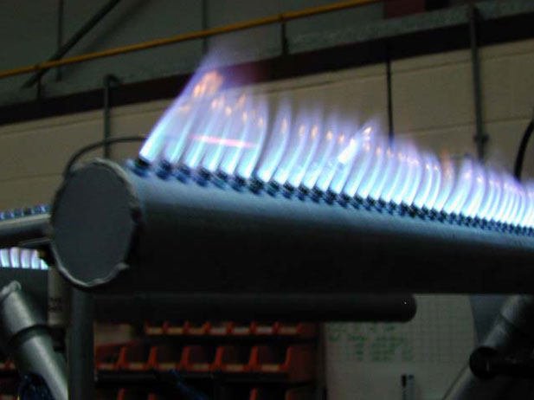
A gas burner used for singing of textile materials

In the sequence of two figures below, one can see the appearance of fabrics before and after singeing. The clean fabric surface after singeing is clearly noticeable.
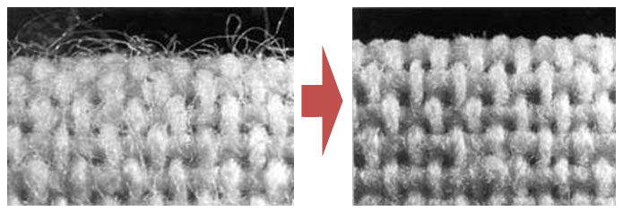
Appearance of fabric after singeing

Since the loose fibres are present on both the surfaces of fabrics, one needs to expose both the surfaces to the action of flame. In the schematic below, one can see the arrangement of burners.
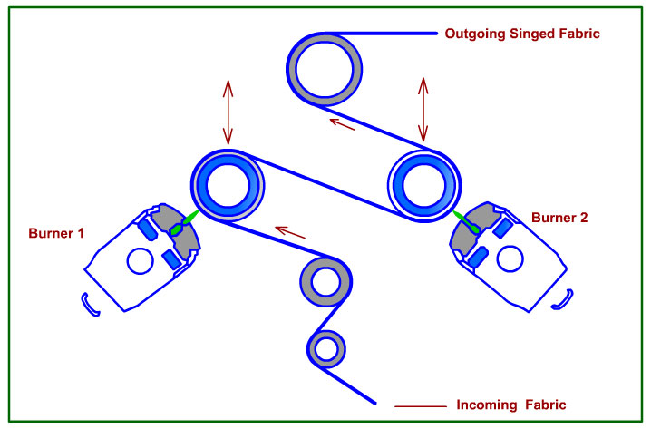
Gas Singeing :
In gas singeing, a suitable mixture of gas and air under pressure is used as the heat source. This mixture is fed into a slot burner where it undergoes combustion. Coal gas, petrol gas or butane gas may be used as the fuel.
The width of the burner can be adjusted to suit different fabric widths. The flame height and consequently the heat intensity can be varied for different fabrics by altering the pressure of the mixture or the ratio of gas and air in mixture.
Upon combustion the temperature of the flame may reach 1300⁰C.
It is important to preheat the cloth to reduce its moisture content before singeing, as a dry cloth performs better than a cold fabric. The heat energy may convert the moisture in fabric to steam which can hinder singeing.
Immediately after singeing, the cloth may be quenched in an aqueous bath to quench any like spark to prevent a potential fire.

PRINCIPLES OF GAS SINGEING:
Singeing is more effective if the loose fibres embedded in the fabric structure can be loosened and brought on fabric surface. To achieve this, many manufacturers today pass the fabric to be singed through beating and brushing devices. The combined action of beating and brushing loosens the fibres and results in more effective singeing subsequently.

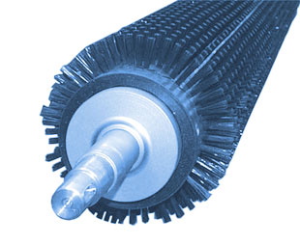
Brushing
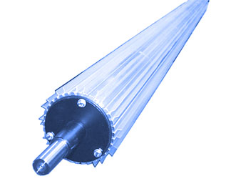
Beating
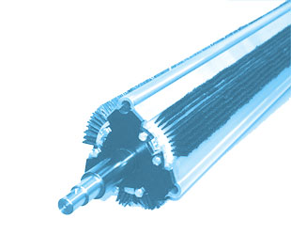
Brushing and beating

Since many fibres are sensitive to direct flame, the position of the burner, i.e., the angle at which the flame strikes the fabric becomes important. The flame can be applied on the fabric in three different ways.
1. Tangential singeing
Here the fabric is exposed to the flame tangentially. Only the protruding fibres are burned-off. This position is especially suitable for the singeing of light weight and heat sensitive fabrics.
2. Singeing on to a water-cooled roller
In this case the flame strikes the fabric at right angle while it is passing over a water cooled roller. The contact of fabric with water cooled roller ensures that the temperature of the fabric does not rise alarmingly. The intense flame quickly converts any moisture in the fabric to steam. This steam and the air in inter-fibre gaps provide a cushion against the penetration of fabric by flame. It is suitable for synthetic and blended textiles and fabrics with open structure.
3. Singeing into the fabric
Here, the flame strikes the free guided fabric at right angles. Absence of any support means the flame can penetrate the fabric and burn off fibres embedded in fabric structure. This configuration is suitable for cellulosic fibres and other heavy technical fabrics made from fibre blends.
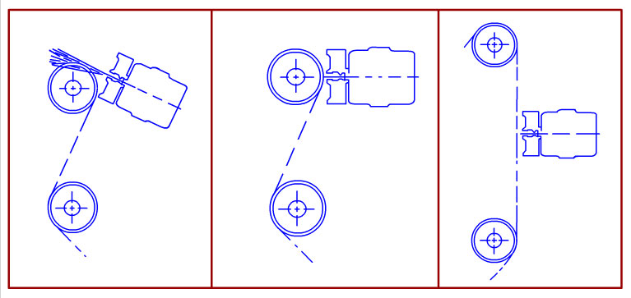
Different burner positions with respect to fabric

4. SINGEING SYSTEMS
Singeing systems can be divided into two categories.
DIRECT – where the fabric has direct contact with heat source. Examples are - Plate, Rotary Cylinder, Gas singeing. Cloth is passed through the machine in open width form.

Plate singeing machine
Plate singeing machine consists of 1-2 inch thick copper plates which are heated from below by burning heavy petroleum oil. The plates are heated to a bright red color and the fabric passes over the plates at speeds up to 200 yards per minute. A special traversing arrangement is provided to prevent local cooling which may occur due to constant passage of cloth over it. The singed cloth is then run through water to extinguish the spark.
Rotary cylinder machine
Cloth passes over a hollow cylinder. It rotates slowly in a direction opposite to that of fabric.
It is fired internally.
INDIRECT systems
Thermal energy produced by the source is used for burning the fibres and there is no contact between the heat source and fabric. Example– Radiation Singeing.
Here fire-proof ceramic blocks are heated to a high temperature, which radiate infrared radiation. This radiation can heat the fibres to such an extent that they can burn. The advantage of indirect singeing are:
No Flame Contact, hence safer approach
Uniform Singeing, as radiation can be distributed uniformly around a fabric surface.

