PRODUCTION OF YARNS:

Yarn Spinning
Yarn spinning is a process of making or converting fiber materials into yarns.^{[1]} Since few centuries ago, spinning have been known as a process of converting raw materials(fiber) such as cotton and wool into yarns for making textile fabric or products. There are two classes of spinning process have been developed by people, Hand Spinning and Machine Spinning. In Textile Industry, the size of yarns is determined by unit of Tex, Count, Worsted, Woolen, and Denier.
In the beginning the yarns were spun by man with bare hands without the aid of any tool and it must have been many centuries before the spindle was evolved for spinning. The spindle or “takli” still survives as a tool hand spinning wool, silk and cotton yarn.
It is the simplest tool which consists of a round disc which is attached in the center to a thin, smooth rod about inches long. The upper end of the rod has a groove or a hook which bulk of the fibres, these are drawn out in a long stand. The spinner while simultaneously pulling the fibres, gives a twist to the spindle and let it go. The spindle whirl around and thus twisting up the pulled fibres makes a continuous thread. The thread is then woven round the rod above the disc. The disc provides the necessary weight which quickens increases and prolonged the revolving of the rod, thereby the twisting of the fibre ensures a strong thread.
Who does not know the “charka” in India.
A charka is used for spinning yarn in the handloom industry in India. The yarn spun on the charkha is of various qualities. The famous “Dacca Muslins” which were incomparable for their fineness but alas are extinct now were woven of a charka yarn. The inimitable soft and light pashmina of Kashmir are still woven of the charkha spin yarn.
Charkhas are of various types. In the textile industries today electrically driven machines are employed for spinning. Several machines are used to complete the process of spinning, which consists of stages such as drawing out of fibre to reduce size and to give slight twist-roving and then spinning. There are two general methods of procedure. In one process, the action of drawing, twisting and winding is continuous and this is called ‘ring’ spinning and in the other, the drawing and twisting is stopped while the twisted thread is wound up (as in the case of hand spinning) and this is known as ‘mule spinning’. The ring spinning is a quicker process and has the advantage of reducing operating cost and increase production, but the mule spun is finer, softer and of greater evenness.
In spinning yarns, whether by hand or machine a difference has to be made in the yarn intended for warp and weft or filling. The warp yarn needs a greater amount of twists to produce a strong firm thread which is used for the foundation of the fabric. The yarn is given twists of specified number of turns per inch. At first, a continuous thread or a strand is made from fibres and several of these strands are twisted together to get a final yarn.
Depending upon the fibres, the preparatory methods of spinning are classified into two types:
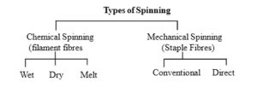
Man-made fibers are made into yarns by chemical spinning.
There are three types of chemical spinning.
Wet spinning
Dry spinning
Melt spinning

Filament yarns spinning is simplest and least stages require compare with Staple yarns spinning. The molten polymer of synthetic will be inserts into a vessel, after few colorations have been done, the solution will be pushed out through the spinnerets to become filament yarns.
- 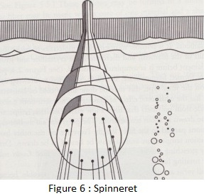
Wet Spinning
Wet spinning is required for polymers that require dissolving in a solvent to be spun. It is named wet spinning because the fibres are extruded directly into a liquid bath. Being extruded into a liquid provides a greater drag force on the Filament? than those extruded directly into air, therefore the speeds at which this occurs is reduced from that of melt and dry spinning. Once evaporated these fibres then have to be drawn or stretched in order to orient the polymers to give the fibre its strength.
The fibre solution is extruded into a liquid that will draw out the solvent, leaving behind only the polymer. The rate at which this occurs is crucial, as if it occurs too quickly the bath liquid can create micro-voids in the fibre which will be a weak points.
Wet spinning is based on precipitation, where a polymer is drawn through a spinneret into a non-solvent. The prepared spinning dope is extruded into the non-solvent and precipitation or coagulation occurs.
Fibres spun using this process include Acrylic, Rayon, Aramid, and Spandex.
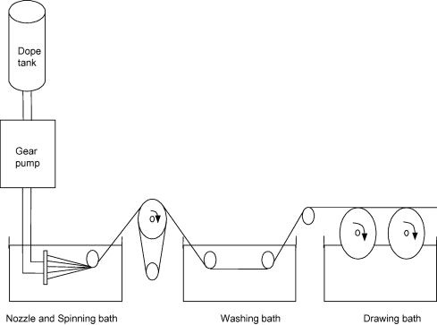
Dry spinning
In dry spinning the polymer is dissolved in its solvent and then extruded, as the fibres emerge through the spinneret the solvent is evaporated off with hot air, in most cases this is then collected and re-used. Figure 3 illustrates the process. Dry spinning is required for polymers with a melt temperature equal to or close to their thermal degradation temperature, therefore they require dissolving in a solvent in order to be processed into fibres.
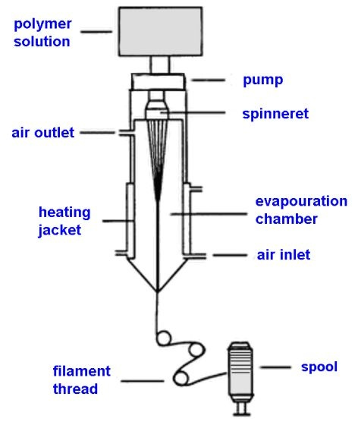
Melt Spinning Process:
Melt spinning is the most convenient and economic method for polymer fiber manufacturing at industrial scales. In melt spinning, the fiber-forming substance is melted for extrusion through the spinneret and then directly solidified by cooling. Melt spinning uses the heat to melt the polymer to a viscosity suitable for the extrusion through the spinneret. As the name indicates the chips of fibers are melted and extruded through the spinneret to obtain the fibers. It is used for the polymers that are not decomposed or degraded by temperatures necessary for extrusion. Polymer chips obtained from previously reacted chemical combinations are melted and then pumped through a spinneret in an air chamber. The extruded stream cool and solidify into continuous filaments and are then drawn out of the chamber twisted and/or processed further and subsequently wound onto spools. This method of spinning is suitable in manufacturing the polyester yarns.
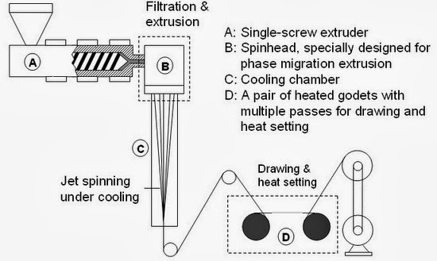
Melt Spinning Process
Melt spun fibers can be extruded from the spinneret in different cross-sectional shapes (round, trilobal, pentagonal, octagonal, and others). Trilobal-shaped fibers reflect more light and give an attractive sparkle to textiles.
Pentagonal-shaped and hollow fibers, when used in carpet, show less soil and dirt. Octagonal-shaped fibers offer glitter-free effects. Hollow fibers trap air, creating insulation and provide loft characteristics equal to, or better than, down.
Mechanical Spinning
Mechanical spinning refers to a multistep procedure in which machines physically manipulate and spin fibres into yarns. There are two types of mechanical spinning. They are

1.Conventional spinning.
2.Direct spinning
Conventional spinning is used to make yarns from natural staple fibres and some man-made fibers. It involves series of machine operations. Direct spinning is used to produce staple yarns from filament fibers.

Conventional spinning
This process is much complicated and requires several stages need to be done before Staple yarns can be produced. In terms of cost production, it is much higher compare with Filament yarns and this means a lot of energy consumption will be waste during this process.
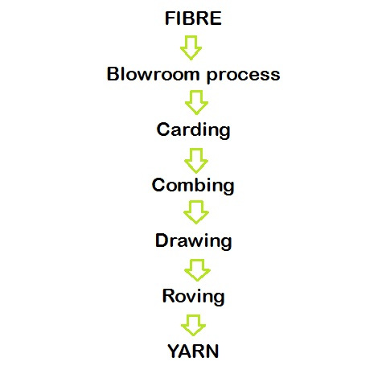
Blowroom
A process where the raw materials packed in bale forms(supplier) will be open and clean the impurities on the surface by using bale opener machine.
1. Ginning
Ginning is the process of separating the lint cotton from the seed.
2. Blending
A Process or processes concerned primarily with the mixing of various lots offibres to produce a homogeneous mass. Blending is normally carried out to mix fibres,which may or may not be of similar physical or chemical properties, market values, orcolours. Blending is also used to ensure consistency of end product.
3. Opening
Covers the initial treatments given to raw cotton. the separation and opening upof the cotton to remove compression because of baling and shipping. Heavierimpurities are also removed from the stock.
4. Picking
The final operation in the cotton system preparation line, in which the cottonflocks are opened mechanically, cleaned, and formed into a lap of specified massper unit area, for feeding to a carding machine.

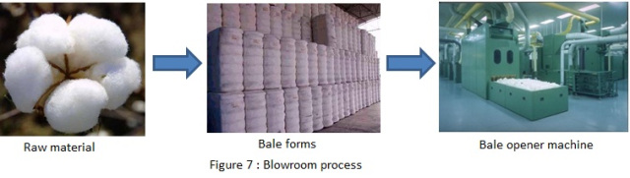
Carding
It’s the heart of spinning process. This is where the flock from bales will be open into individual fiber. Thus, it will ease to remove the excess impurities on the fiber surface. At this point, short fiber which not suitable for production in terms of length requirements will be eliminated.
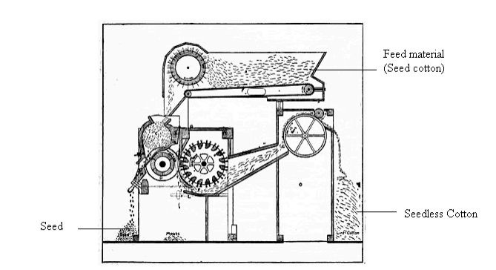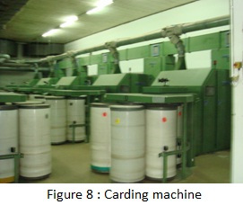

Combing
This is a process where the yarn will be straightened again so that they are arranged in parallel manner. While at the same time, the remaining of short fiber will be eliminated completely from the longer staple fiber. By doing this, long-staple will produce stronger and smoother fabric which are highly demanded in the market. ^{[2]}
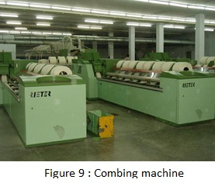
Drawing
At this stage, it will be pulled the sliver lengthwise direction over each other. Thus, it will cause it to be stronger and thinner in production which is very important in evenness of the yarn. If there is any faults occur during process, it will still pass into the yarn. Most of manufacturer will use blending process where two or more different types of fibers will be blended to form a yarn. Common type of blend use is Cotton/Polyester combination, by doing this it will not only reduce the cost but also increase the performance. ^{[2]}
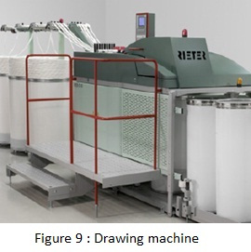
Roving
This is the final stage where the preparatory steps for insertion of the twist. Enough twist is given to hold the fibers together but still has no tensile strength. The roving in bobbins is placed in spinning frame where it passes several sets of roller which running at high-speed to convert into yarn forms. ^{[2]}
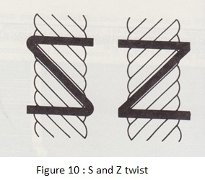
Spinning
This is the final operation for formation of yarn of desired size. The spinning frames complete the manufacture of yarns by performing operations such as drawing the roving, inserting twist and winding yarn on bobbins, all in one operation.
The roving on bobbins is fed through sets of rollers on spinning frame. Just as in roving, the front set of rollers rotates faster than the back set. This difference attenuates the yarn and makes it even, smooth and uniform.
Two types of spinning frames are commercially employed. For relatively high speed production and making coarser yarns, ring frame is used. For finer yarns, mule frame is used, which operates at low speed. On ring frame, the attenuated yarn is fed down, guided through a ‘U’ shaped guide called a ‘traveller’ on to a take up package or bobbin. The traveller moves around the take up package at a slower speed than the take up package. Hence the name ‘ring spinning’. The movement of the traveller and the turning of the spindle on which the bobbin is held combine to introduce twist into yarns. The spindle revolves about 13,000 revolutions per minute. The size of the yarn and the amount of twist (turns per inch) can be controlled. The yarn on bobbins may be reeled into skeins or wound on spools for weaving and further processing.
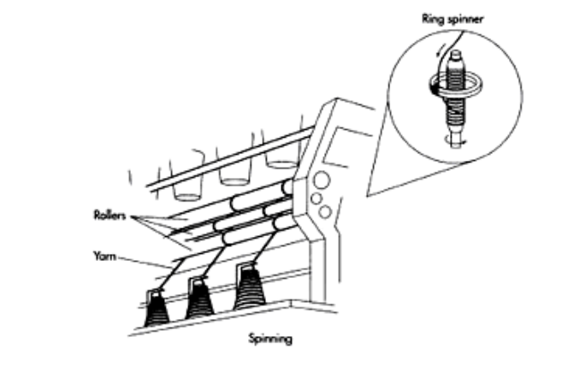

Direct spinning
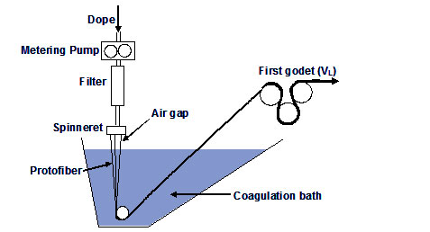
Filament fibres stretched
Breaking > Drawing > Roving > Spinning
Several common systems used by the manufacturer in spinning industry for Staple yarns;
- Conventional Ring Spinning,
- Air-jet Spinning,
- Open-end or Rotor Spinning

Definition of Yarn
Yarn can be defined as a linear assembly of fibers or continuous filaments formed into a continuous strand which is having the required characteristics for textile. These textile characteristics referred to include the good tensile strength & high flexibility so that it can be pliable & to be considered to a yarn, these yarns must be process able on conventional textile equipment & must possess the visual & aesthetic characteristics which are usually associated with textile products. Combination yarns are made by plying the dissimilar components such as staple & continuous filament yarns
CLASSIFICATION OF YARN

- Spun Yarn
- Filament Yarn
- Novelty Yarn

Staple Yarns/ Spun yarn
There are four different system of manufacturing the staple yarn on the commercial level. These four systems are-
- The carded cotton yarn system
- The combed cotton yarn system
- The worsted yarn system
- The woolen yarn system

In all these four systems of the yarn is made from the staple fibers is nothing but the fibers which are limited in length. The yarn which is made or formed from the staple fibers is known as staple yarn. The carded cotton & combed cotton system are used to spin yarn from the short (up to 1 inch) & long (2-3 inch) staple cotton & similar fibers.

The woolen & worsted system are used to spun yarn from the short (up to 2.5”) & long (up to 3.9”) staple fibers & similar fibers.

Manmade fibers are usually cut to a fiber length, diameter & crimp resembling that of cotton & wool for processing on this system.

The fabric made from staple yarn have the good tactile properties such as a good handle, feel & excellent comfort along with the good aesthetic appearance.

2. Continuous Filament Yarn
Before the discovery of the manmade fibers, silk was the only filament yarn.
In the manufacturing manmade filaments, a solution is forced through very fine holes of a spinneret, at which point the solution solidified by coagulation, evaporation or by cooling.
The number of holes in a spinneret determines the number of filaments is the continuous filament yarn.

The size of hole and drawing (if any drawing) then it determines/ affects the diameter of the filament. As soon as the individual filament solidifies, they are brought together with or without slight twist or entanglement to form the continuous filament yarn.

The main advantage of manmade continuous filament yarn is the physical and chemical properties of these yarns are can be altered as per the end use requirement.

The fabric made from continuous filament yarn is much stronger & uniform. Continuous filament yarn is much stronger & uniform than staple spun yarn.

But manmade continuous filaments are lack in their comforts properties, tactile properties, good covering properties & pleasing appearance in their un textured form.

Classification of yarn according to the number of parts in Yarns
- SimpleYarn
In the construction of easy yarn, just one quite fibre is employed. The way during which the fibres square measure twisted are a similar throughout the length of the yarn. Yarns square measure referred to as easy, ply or cable relying upon the amount of strands they contain.

- SingleYarn
In this, variety of fibres square measure twisted along into an eternal length. The yarns consist of one quite fibre. This sort of yarn is that the one typically found in most traditional materials for wear and house use and functions.
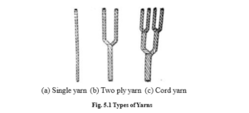
Single Yarn, Ply yarn and Cord yarn
- Folded or Plied Yarn
A yarn in which two or more single yarns are twisted together in a single operation, for example two-fold, three-fold, four fold.
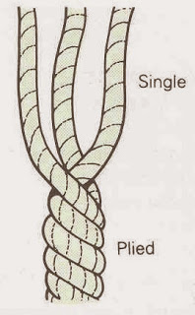
Folded or Plied Yarn
- Cabled yarn
A yarn in which two or more folded yarns are twisted together in one or more operations. Folded and cabled yarns can be produced from staple yarns, continuous filament yarns or a combination of both.
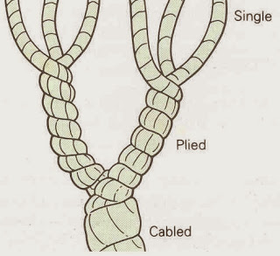
- Double Yarn
This consists of 2 or a lot of single strands treated joined within the weaving method, however the strands aren’t twisted along. These square measure used for decorative result because the low twist yarns manufacture luster and softness.

Classification according to the twist direction
Yarn twist: Twist is that the spiral arrangement of the fibres round the axis of the yarn. Revolving one finish of the fibre strand whereas the opposite finish is command stationary produces twist. Twist binds the fibres along and offers the small stuff strength. it’s how to vary the looks of materials. the amount of twists is stated as turns per in.. they need a right away relating the value.
Twist is that the spiral arrangement of the fibres round the axis of the yarn. Revolving one finish of the fibre strand whereas the opposite finish is command stationary any produces twist. Twist binds the fibres along and to offers the yarn. Higher twist that yields lower productivity.
Direction of Twist. The direction of twist is delineate as
- s-twist and
- z-twist.
A yarn has S twist if once command during a vertical position, the spiral make sure the direction of slope of the central portion of the letter “Z”. Z-twist is that the normal twist used for weaving yarns. the bulk of single yarns ar spun with twist in Z-direction.

NOVELTY YARNS/ FANCY YARNS :
A fancy yarn can be defined as one that differs from the normal construction of a single or doubled yarn by deliberately introduced irregularities in its construction.
The ‘novelty’ or ‘fancy’ yarns produce different textures and effects in the fabrics. Fancy yarns can be made from all natural fibers, all man-made fibers and their blends. They can be produced from pre-dyed or un dyed fibers and yarns.
Fabrics containing fancy yarns are used for many textile purposes, for instance apparel such as dress fabrics, or household textiles such as curtains and upholstery.
Using one or more of the following techniques, novelty yarns may be produced. Combination of different fiber types; combination of different colours of yarns; combination of different yarn linear densities; combination of different yarn lengths.
BASIC FANCY YARN
Generally , fancy yarns contain two or more of the following : a base or core yarn , around which the yarn intended to create the fancy effect is wrapped; the effect yarn , which forms the design ; and the binder which holds the effect yarn in place on the base to prevent it slipping while it is being wound, knitted or woven.
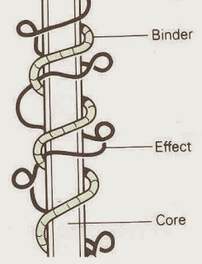
Fancy yarn
Gimp and Loop :
All these fancy yarns are produced by delivering the core and effect yarn at different rates.
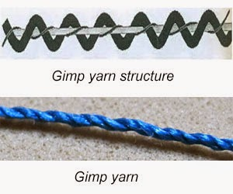

Gimp is a twisted core yarn, with the effect yarn wrapped around the core producing an irregular wavy surface. The effect yarn has a regular semi-circular appearance, while in loop, the effect yarn appears as well-formed circular loops.
Snarl :
This is made in the same way as a loop yarn, but using a highly twisted effect yarn which forms snarls rather than loops.
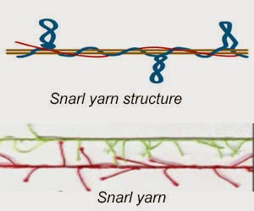
Spiral/Cork screw :
The basic spiral structure is formed by plying two yarns together so that one yarn spirals around the other as shown in Figure. Spiral yarns are also called corkscrew yarns due to their appearance
A plied yarn, in which one of the components wraps around the other, rather than the components twisting regularly together under the same tension. A spiral yarn tends to have a higher twist than a corkscrew yarn.
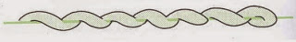
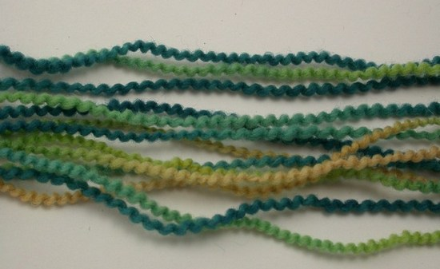

Slub :
This is composed of short, abnormally thick places at regular or irregular intervals. The slub effect is spun into the yarn .
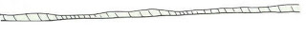
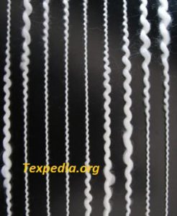Slub yarn
Cloud :
A two-colour yarn, in which both yarns take it in turn to obscure or cloud the other, giving the appearance of an intermittent colour change.
Cloud yarn
Fleck yarn
Fleck :
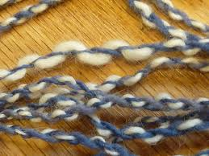

The other name of these yarns is flake yarns. This is one type of novelty yarn. These are usually single yarns in which small amount of fibres either different colours or luster or both are to place by inserting into the yarn and holding in place by twist of base yarn eg: tweed fabric. This gives a spotted and short

Metallic Yarns:
Clothes of metallic threads, of gold or silver, are known to have been made thousands of years ago. Modern metallic yarns are, however, usually only made from laminated plastic films. The films are first coated on both sides with metallic paint of suitable color, a further transparent coating is applied on top to enhance the wear resistance. The films are cut into thin strips to be used as yarns. It is unusual to use these slit film yarns directly in fabrics because of poor abrasion and strength properties. They are often used as a component in a compound yarn. Figure-12 shows an example of a metallic yarn.
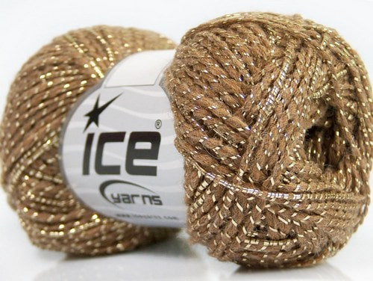
Figure-12: Metallic yarn
SEWING THREAD
Sewing thread is found everywhere, in common apparel, home furnishing, sportswear and shoes, in automotive items like air bags and seat belts as well as invarious other technical applications. The sewing seam performances of thesewing thread are influenced by material to be sewn, sewing techniques and theend use desired.
Sewing thread functions
Sewing thread covers two main functions; the most important is obviouslyjoining the different fabrics and give the product the necessary strength in thearea of its highest stress – the invisible seams. The second function is refiningproducts with decorative stitching. In both cases one thing is oftenunderestimated: Sewing Thread may account only for 0,5% of fiber amountwithin a garment, however, it shares fairly more than 50% of responsibility forthe final quality of a garment.
The requirements can be defined as:
• The ability of sewing thread to meet functional requirements of producingdesired seam effectively.
• Ability to provide desired aesthetics and serviceability in the seam.
• Cost of the sewing thread and that of resultant seam.
1. Functional requirements
Tensile properties: Sewing thread should have high tenacity with moderatetension. For better loop formation characteristics, the elastic modulus of thesewing thread should be high.
Friction: There should be uniformity of friction over long length. Factors areresponsible for giving maximum possible tension fluctuation of the yarncomponents in the cross section and the length.Passage through needle eye: There should be no sudden shocks when threadpasses through the eye of the needle. Needle temperature is critical for sewingthread of man made fibres.Free from knots and faults: Sewing thread should be free from knots and faultsto give smooth performance.
2. Serviceability
During sewing, threads are subjected to abrasion over needles and fabricthreads. There is a lose of strength during and after sewing during fabric use.Sewing thread should have high abrasion resistance so that lose strength isminimum. For a good serviceability, seam must be firm. A seam strength testcould be performed. Different stitches are applied to different application. Fabricproperties affect seam strength along with loop and abrasion strength of sewingthread and the amount damage due to sewing. To avoid puckering of garments around the seams, the thread shrinkage should be generally less then 2% duringwashing.
3. Aesthetic
Colour, shade, luster, smoothness, fitness are some of aesthetic relatedcharacteristics of sewing threads. Certain amount of hairiness in sewing threadhas to positive effect on sewing but this effect has to be sacrificed forappearance. There is a tendency to use dyed sewing thread for appearance.
4. Cost consideration
From the raw material aspect, sewing thread of natural silk is expensive. Ahigher melting sewing thread may be expensive. but, it should have a judicioususe in the sense that the fabric for which it is used should also have a highmelting points as the hot needles not only attack the sewing thread but thefabric also.
5. Other sewing thread properties
In addition to the essential properties, some of the applications may be requiredfor sewing threads to have special properties like, resistance to flexing in seamsin shoes, discontinuous surface to provide grip and avoid slippage in the seamfor high seam strength applications.

