Definition Of Loom
Loom is a machine or device which is used to produce woven fabric by interlacement of warp and weft yarn. Ginning, opening, cleaning, carding, combing, drawing, spinning, winding, warping, sizing, beaming are the process prior to weaving. All these process converge on loom.
Classification Of Loom
a) Hand loom.
b) Power loom.
HANDLOOM :
A hand loom is a simple machine used for weaving. In a wooden vertical-shaft looms, the heddles are fixed in place in the shaft. This loom is powered by hand. The warp threads pass alternately through a heddle, and through a space between the heddles (the shed), so that raising the shaft raises half the threads (those passing through the heddles), and lowering the shaft lowers the same threads—the threads passing through the spaces between the heddles remain in place.
2. It is a manual operating system.
3. Shedding is done by pressing the treadles pedal and picking and beating is done manually.
4. Hand looms yield less production compared to power loom.
5. It can be operated at slow speed only compared to high speed of power looms.
6. Initial investment is very low compared to power loom.
Basically there are two types of handloom:
- Frame loom 2. Pit loom.
Different Parts Of A Loom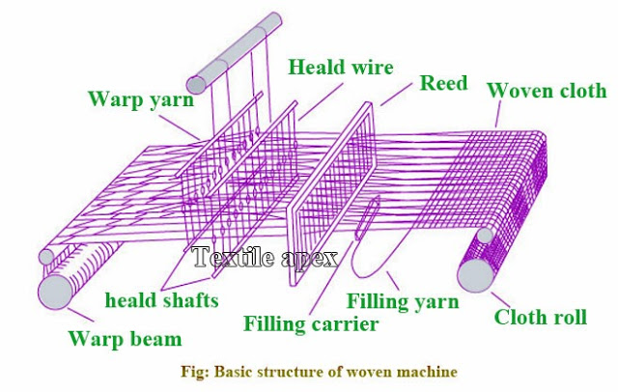
PARTS OF LOOM

Warp Roller: The warp roller which consists of the lengthwise yarns is located at the back of the loom & it releases the warp yarn to the weaving area of the loom as needed.
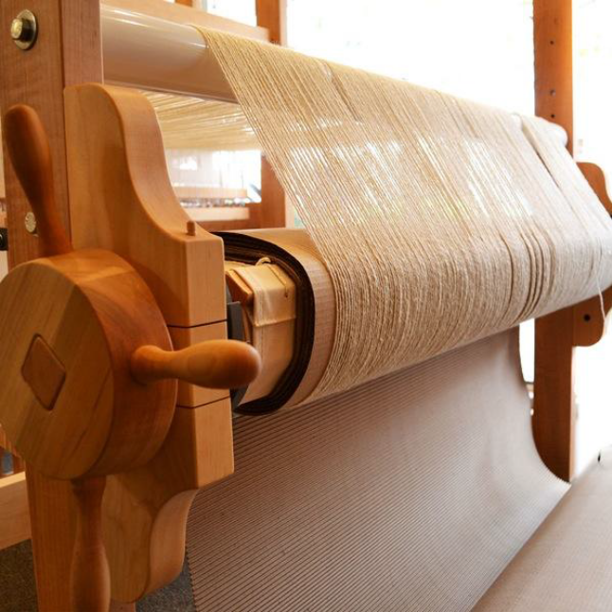
Handle: The handle is provided on the warp roller to tighten or loosen the warp sheet which ultimately changes the tightness factor of the fabric.
Back Beam: To maintain the constant tension and proper angle to the warp sheet.
Heald/Heddle
Wire or cords with eyelets that hold warp yarns in a place.
Heald shaft/Harness
A wood or metal frame that holds the headl/heddles in position in the loom during weaving. It is usually more than one.
Shuttle
This is a vehicle for weft & passes through the divided warp for the interlacement of the warp & weft.

Shuttle box
Compartment of each end of the sley of a shuttle loom used to retain the shuttle between picking motion.

Picker
It is a piece of leather or other metal placed in grooves or on a spindle inside a shuttle box.

Beams
A cylindrical body with end flanges on which a multiple of warp ends is wound in such way to permit the removal of these yarns as a warp sheet.

Front rest
It is a fixed roller placed in front of the loom above the cloth beam & act as a guide for the cloth to wind on to the cloth beam.

Lease rods
The division of warp yarn into one & one, two & two, & so on is termed as lease. The two rods passed between the two successive divisions of warp yarns are called lease rods.

Slay
It is the portion of loom that carries the reed and oscillates between the harness & the fell of the cloth.

Reed
A comb like wire or device used to separate yarns on a loom & to beat up the filling during weaving.

Treadles: These are located at the bottom of the loom and are designed to control warp shed formation by controlling the up and down movement of the heddles. The weaver presses the treadles by their feet for shed formation. The shed on a handloom is controlled manually by giving proper movement to the treadles using foot.
Temple
Roller device on a loom that hold the cloth at a proper width to prevent it from being drawn in too much by the filling.

FUNCTION OF LOOM
Shedding motion: Shedding separates the warp yarns into two layers for the insertion of a pick. The function of shedding mechanism is to raise & lower the heddles. Which carry a group warp ends drawn through heald eye. There are different kinds of shedding mechanism like Tappet, Jacquard etc.
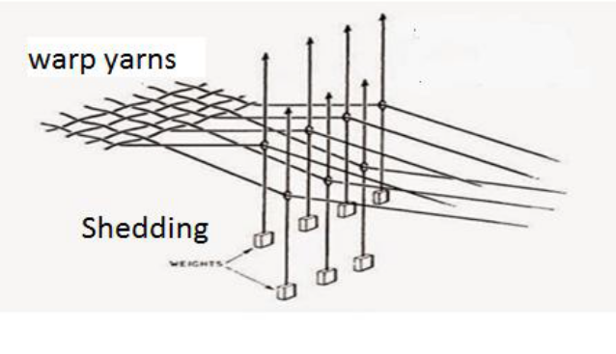

Picking motion: Picking motion inserts a pick (weft) from one side to the other side of the fabric. In Hand looms, pick is inserted with the help of a shuttle through the shed opened by the shedding mechanism. i.e. between the two layers of warp shed.
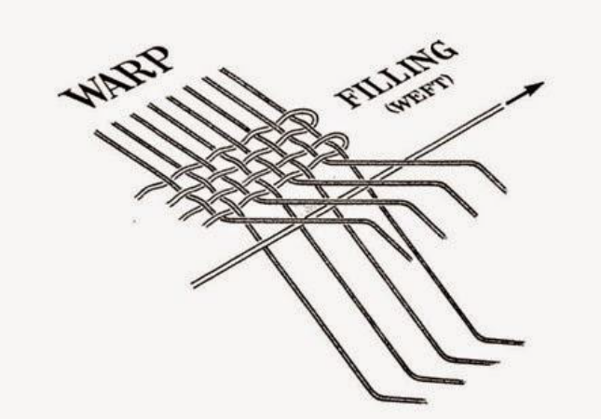

Beating-up: The function of beat up mechanism is to push the weft thread that has been inserted across the warp threads in a shed, up to the fell of cloth. Fell of the cloth is the position of the last pick in cloth woven on the loom. The beatingup of the weft to the fell of cloth is carried out by the beater.
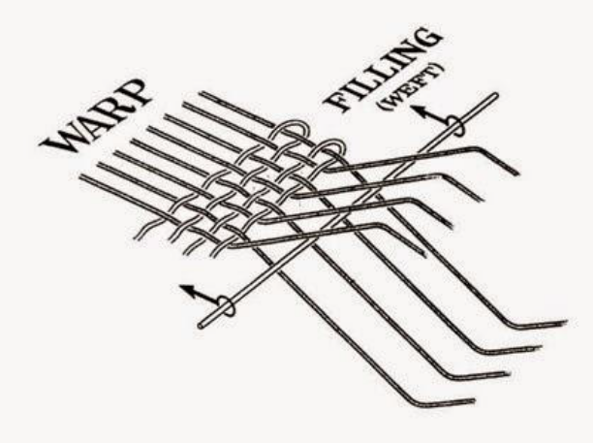
Take-up motion : Take- up motion winds the fabric as being manufactured.It means after the beat up of the weft, woven cloth is drawn away from the reed. After weaving a suitable length, the weaver rolls the fabric on the cloth roller with the help of take up motion handle and continues the weaving.

Let-off motion Let- off controls the amounts of warp delivered and maintains the regional tension during weaving. This motion delivers warp to weaving area at the required rate and at a suitable constant tension by unwinding it from warp roller. The weaver has to manually adjust the weight on the tension lever to maintain the tension of warp sheet.

Advantages of Pit Loom:
Texture fabric is produced by using this loom.
Higher production in pit loom.
It can accommodate a great quality of weft yarn in the pirn winding package.
An average weaver can weave in case of pit loom.
Easy control of moisture here.
Flu shuttle and back beams have been introduced here to remove some fabric faults such as yarn breakage, knot etc.
Disadvantages of Pit Loom:

Too tough to control more number of heald shaft.
This types of loom set up is difficult.
Pit loom is one types of hand loom, so it’s tough to achieve higher production from here.

Frame looms
Frame looms almost has similar mechanism that ground looms hold. The loom was made of rods and panels fastened at the right angles to construct a form similar to a box to make it more handy and manageable. Frame loom is being utilized even until now because of its portability and economy.

Features of Frame Loom
Some key characteristics of frame loom have pointed out in the following:
Twill, satin fabric can be produced by using this types of loom machine.
The movement of the slay is given by the left hand of the weaver.
This types of loom is made on a frame
Beam diameter may high in case of frame loom.
Advantages of Frame Loom:
Advantages of frame loom in weaving are in the below:
Here, long width of fabric can be woven as narrow ones.
It has increased speed as one hand of the weaver operates the picking handle and the other remains free to operate the slay.
Ensure better selvedge here.
Larger number of heald can conveniently be operated.
Let off is done here by pawl lever arrangement.

Disadvantages of Frame Loom:
Those are in the following:
Fabric may compact in frame loom.
Here, its too tough to fit the level.
Cloth beam diameter is increased here as a result it becomes very large.

Shuttle Loom
The shuttle loom is the oldest type of weaving loom which uses a
shuttle which contains a bobbin of filling yarn that appears through a hole
situated in the side. The shuttle is batted across the loom and during this
process, it leaves a trail of the filling at the rate of about 110 to 225 picks per
minute (ppm). Although very effective and versatile, the shuttle looms are slow
and noisy. Also, the shuttle sometimes leads to abrasion on the warp yarns and at
other times causes thread breaks. As a result, the machine has to be stopped for tying the broken
yarns.

Shuttleless loom
Many kinds of shuttleless looms are used for weaving such as Projectile
Looms; Rapier Looms; Water Jet Looms, and Air Jet Looms.

Projectile Loom
A weaving machine in which the weft thread is gripped by jaw(s) fitted in a projectile, which is then propelled through the shed. It has a small hook-like device that grips the end of the filling yarn.It is sometimes called missile loom as the picking action is done by a series of small bullet like projectiles which hold the weft yarn and carry it through the shed and then return empty.
All the filling yarns are inserted from the same side of the loom. A special tucking
device holds the ends of the wefts in place at the edge of the cloth to form the selvage. This loom needs smooth, uniform yarn which is properly sized in order to reduce friction. Projectile loom can produce up to 300 ppm and is less noisy than the shuttle loom.

Rapier Loom
Rapier looms are machines in which the means of carrying the weft through the shed is fixed at the end of a rigid rod or in a flexible ribbon, this being positively driven.
A rapier machine may have a single rapier to carry the weft across the full width or a single rapier operating bilaterally with a centrally located bilateral weft supply, or two rapiers operating opposites sides of the machines.
Rapier loom comes in many types. Early models of it use one long rapier device that travels along the width of the loom to carry the weft from one side to the other. Another type of rapier loom has two rapiers, one on each side of the loom. They may be rigid, flexible or telescopic.
One rapier feeds the weft halfway through the sheds of warp yarns to the arm on the other side, which reaches in and carries it across the rest of the way.
Rapier looms are very efficient and their speed ranges from 200 to 260 ppm. These looms can manufacture a variety of fabrics ranging from muslin fabric to drapery fabrics and even upholstery fabrics.

Water Jet Loom
In water jet loom, a water jet is propelled across the shed with the force, that takes the filling yarn to the other side.
In it, a pre-measured length of weft yarn is carried across the loom by a jet of water. These looms are very fast with speeds up to 600 ppm and very low noise. Also, they don’t
place much tension on the filling yarn.
As the pick is tensionless, very high quality of warp yarns are needed for efficient operation. Also, only yarns that are not readily absorbent can be used to make fabrics on water jet looms such as filament yarn of acetate, nylon, polyester, and glass. However, it can produce very high-quality fabrics having a great appearance and feel.

Air Jet Looms
In air jet loom, a jet of air is projected across the shed with the force, that takes the filling yarn to the other side ie. a jet of air is used to propel the weft yarn through the shed at speeds of up to 600 ppm. Uniform weft yarns are needed to make fabrics on this loom.
Also, heavier yarns are suitable for air jet looms as the lighter fabrics are very difficult to control through the shed. However, too heavy yarns also can’t be carried across the loom by an air jet. In spite of these limitations, air jet loom can produce a wide variety of fabrics.

Passage of Material through Loom (Line diagram)
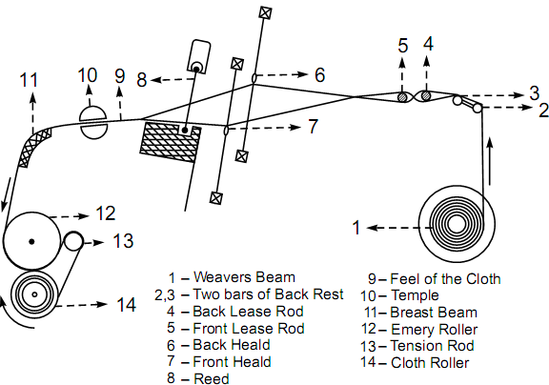
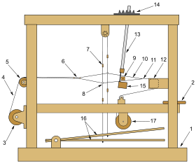
Elements of a foot-treadle floor loom
- Wood frame
- Seat for weaver
- Warp beam- let off
- Warp threads
- Back beam or platen
- Rods – used to make a shed
- Heddle frame - heald frame - harness
- Heddle- heald - the eye
- Shuttle with weft yarn
- Shed
- Completed fabric
- Breast beam
- Batten with reed comb
- Batten adjustment
- Lathe
- Treadles
- Cloth roll- takeup

Dobby Loom

A type of floor loom, dobby looms are great for larger, complex projects and use a special device that controls all the warp threads, making weaving complex patterns a more comfortable experience. Dobby is short for “draw boy” which refers to the weaver’s helper who was used to control the warp thread by pulling on draw threads. The dobby mechanism is used to program the harness combinations for the weave pattern. All of our dobby looms are available with either a mechanical or electronic dobby. An investment in a Louet Dobby ensures many years of comfortable and productive weaving.

A Dobby Loom is a loom in which each harness can be selected without using treadles; a manual dobby uses a chain of bars or lags each of which has pegs inserted. The pegs select the harness to be moved. A computer assisted dobby loom uses a computer program to select which harness is to be moved. In either case the harnesses are lifted or sunk by either legpower on a dobby pedal or electric or other power sources. This is in contrast to a treadle handloom, where the harnesses are attached by cords to a limited number of different treadles to select and move the harnesses.
Dobby looms allow a huge variety of weave structures which a treadle loom might not, due to the lack of treadles. A floorloom is limited in the amount of treadles it can use within the loom frame, but a dobby need only add bars to the dobby chain to enlarge the loom's weave capacity. A normal eight harness floorloom has ten or twelve treadles but a dobby device mounted on the same loom will use a chain of bars ranging from twelve to seventy. The average dobby chain will have approximately fifty bars.
JACQUARD LOOM:
Jacquard designed this loom to use a series of punch cards that would correspond to certain hook activities that would raise or lower the loom harness. Operators could change patterns simply by changing the punch cards.
A Jacquard loom is an example of an adaptation from a dobby loom. A Jacquard device mounted a top a loom will lift the individual heddles and warp threads. The individual heddles and warp threads can be controlled by a computer or a series of punched cards which select them to rise or fall. Power is usually supplied to the loom to move the many heddles involved.
General Characteristics of Jacquard Mechanisms:
- For designs that require the reproduction of freely drawn shapes , it is usually necessary for each end in the repeat to be separately controlled.
- Jacquard machines are used for a wide variety of purposes from ties to carpets.
- Their patterning possibilities virtually unlimited.
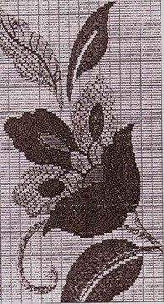
Jacquard mechanism fabric
- The most elaborate designs (reproduction of freely drawn shapes, i.e. floral designs) are woven on an intricately constructed loom called the Jacquard loom, and the weave of these fabrics is called the jacquard weave .
- Elaborate designs could not be made on the regular harness loom. Because intricate designs require many variations in shedding.
- Virtually no limit to the number of picks /repeat (i.e. 5000 picks or more)
- The length of the repeat is limited only by the cost and inconvenience of a very long pattern chain .
- Jacquard machines are made in a wide variety of sizes to control from 100 to 2000 or more ends per repeat.
- In conventional jacquard machine field, the spectrum now ranges from 192 through 3200 to 6144 hooks.
- When a higher no.of independent lift is required two or three jacquard machine is placed side to side.
Advantages:
- Tremendous design possibilities,
- Simpler in principle than dobbies
Disadvantages:
- Large scale moving parts makes the machine and its harness relatively costly to install and maintain.
- Jacquard fabrics are much more costly to produce.
- Jacquard machines are even more liable to produce faults in the fabric than dobbies.
- Pattern change is a time consuming process.
- Until recently, the jacquard machine had tended to impose limitations (300 picks/min )
- Jacquard shedding is normally used only when the cloths to be woven are outside the scope ofdobby shedding.
The threads which must work together are collected in the same heddle and joined to a counterweight by means of a string hanging from above. You can see these strings in the photo on this page;
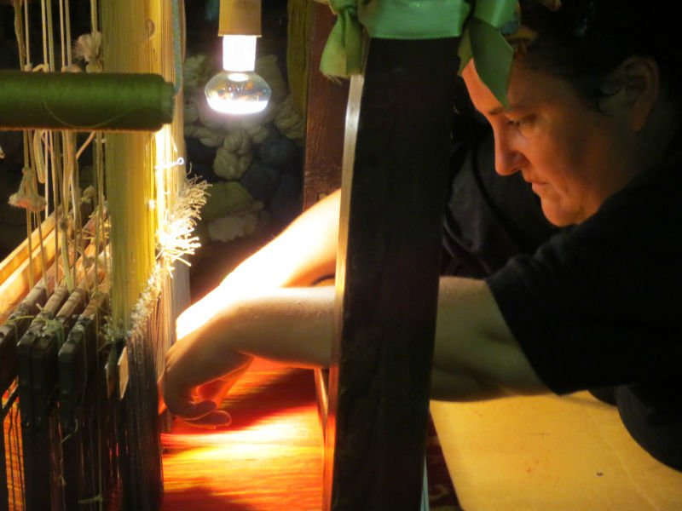
Each string is connected to a series of punched cards, placed on a rotating cylinder. The holes on every piece of pasteboard correspond to the pattern which will appear on the fabric.
The holes on the pasteboard let only the corresponding counterweights fall: if the card has a hole through which the string can pass, then the weight falls and lift only the warp threads connected to it. All other warp threads remain where they are;
The weft threads can thus interweave with the weft and create the pattern;
\
After that, the weaver pushes this weft yarn with abeater and makes the punched cards move forward. So the strings find new holes and the pattern can keep on growing.

