KNITTING
The second most important fabric construction method after weaving is knitting. Knitting is the process of making loops and throwing the yarns through loops to form a fabric. In the earlier days knitting was con-sidered as a unique technique of making fabric using wool fibres. The oldest knitted products are socks found in Egypt tombs. Knitting is done using long stick like nee-dles. The first knitting machine was invented in 1589, by Reverend William Lee. It slowly developed and today the market is filled with complex knitting machine to produce a huge range of knitted fabric.
Knitted Fabric Making
Knitted fabric is constructed by forming the yarns into loops. The vertical rows of loops stitches in knit fabric are known as wales and the horizontal rows of loops are called courses. The loops are formed by a group of needles or shafts, which are arranged one after the other in the knit-ting machine on the needle plate. The needles are evenly placed. Sinker is used to pull the needles down, which pulls the yarn into the previous loop. The knitted fabric is pulled down and rolled at the base of the machine and collected for fur-ther use.
Classification of Knitting
Knitting is divided into two main groups as warp and weft knitting. Warp knitted fab-rics are produced by a series of yarn forming loops in the lengthwise direction of the fab-ric. Weft knitted fabrics is produced when one continuous yarn forms the loops in the crosswise directions. The most common types of warp knitt fabrics are Tricot knit, Raschel, Milanese and Simples knit. The different kinds of weft knits are plain, purl and rib. Both weft and warp knitting can be incorporated in the jacquard mechanism to produce fancy knitted fabrics.
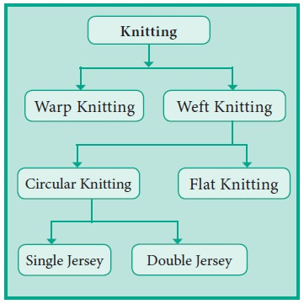
Types of Knitting: Knitting is done by set of connected loops from a series of yarn in warp or weft direction. Knitted fabrics two are divided into two main types. They are-
Warp knitting is a family of knitting methods in which the yarn zigzags along the length of the fabric; i.e., following adjacent columns, or wales, of knitting, rather than a single row, or course. In a warp knitted structure each loop in the horizontal direction is made from different thread. Sweater is made by this warp knitting techniques. For comparison, knitting across the width of the fabric is called weft knitting.
Since warp knitting requires that the number of separate strands of yarn, or ends, equals the number of stitches in a row, warp knitting is almost always done by machine rather than by hand.
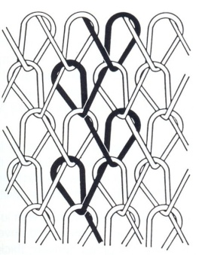
Weft Knitting:
Weft knitting is the simplest method of converting a yarn into fabrics. If the direction of yarn feeding is perpendicular to the direction of fabric formation or if yarn is supplied in a weft or crosswise direction, then this type of knitting is called the weft knitting (Figure). In weft knitting, the loops are formed across width of the fabric. The fabrics formed through this type of mechanism are called weft-knitted fabrics or simple jersey fabrics and the machine used is called the weft knitting machine.
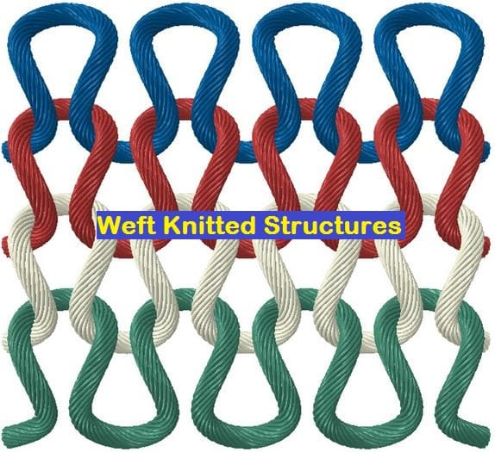
Figure: Weft knitted structure
Weft knitting machines may be flat or in a circular form. Mostly latch needle are used in weft knitting. Both natural and synthetic yarn can be used in weft knitting. There are grooves or cuts on the cylinder or dial of machines at regular intervals. The number of cuts in unit length is called the gauge of the machine. The finer the gauge, the more will be the number of needles per unit area. On the basis of needle beds, the machines are classified as single bed or double bed.
Circular knitting or knitting in the round is a form of knitting that creates a seamless tube. When knitting circularly, the knitting is cast on and the circle of stitches is joined. Knitting is worked in rounds (the equivalent of rows in flat knitting) in a spiral.^{[1]} Originally, circular knitting was done using a set of four or five double-pointed needles. Later, circular needles were invented, which can also be used to knit in the round: the circular needle looks like two short knitting needles connected by a cable between them.
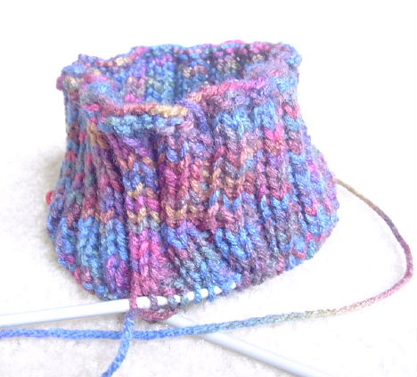
Flat knitting is a method for producing knitted fabrics in which the work is turned periodically, i.e., the fabric is worked with alternating sides facing the knitter. Another method of reaching the same result is to knit alternately from right to left and left to right without turning; this back-and-forth technique requires either innate or learned ambidextrous motor skills. The two sides (or "faces") of the fabric are usually designated as the right side (the side that faces outwards, towards the viewer and away from the wearer's body) and the wrong side (the side that faces inwards, away from the viewer and towards the wearer's body).

Different between warp and weft knitting: Basically warp and weft knitting process are totally different from one to another. Following are the difference of warp and weft knitting.
Warp knitting | Weft knitting
The loops are produced to the length of fabric | The loops are produced to the width of fabric
It is elastic to the length | It is elastic to the width
Elasticity of the warp knitted fabrics is less than weft knitting | Elasticity of the warp knitted fabrics is higher than weft knitting
Its shrinkage properties is less | Its shrinkage properties is higher than warp knitted fabric
Here courses are needed for pattern row | Courses are equal to the pattern
Yarns are supplied from heam | Yarns are supplied from cone

Uses of Knitting
Knitted fabrics are used for
Clothing (Underwear, Sweaters)
· Home furnishing (Curtains, Towels)
· Medical textiles (Grip Bandages)
· Industrial textiles (Wipes, Absorbent Pads)
TERMS IN KNITTING
Course :
The series of loops those are connected horizontally, continuously are called as course.
The horizontal row of loops that are made by adjacent needles in the same knitting cycle.

Wales :
The series of loops that intermeshes vertically are known as Wales.
Vertical column of loops that are made from same needle in successive knitting cycle
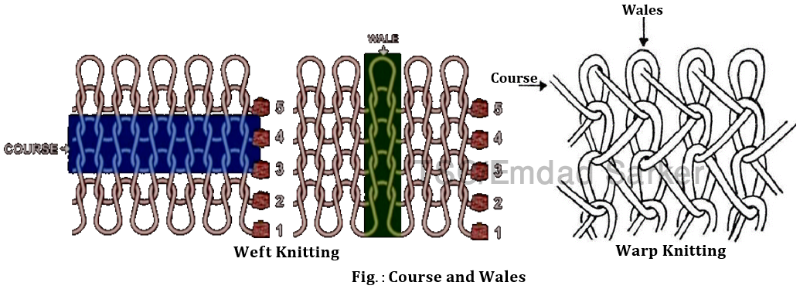
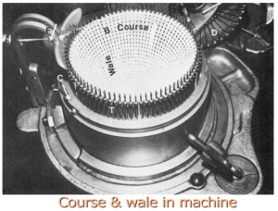
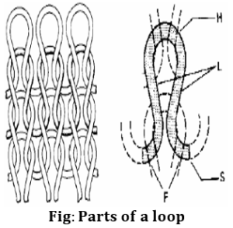

Needle loop:
Needle loop is the upper part of the loop produced by the needle drawing the yarn.

Sinker loop:
The lower part of the knitted loop is technically referred as sinker loop. It is the connection of two legs belonging to neighboring stitches lying laterally.

Open loop:
The open loop is one in which the loop forming yarns do not cross at the bottom of the loop.

Closed loop:
In closed loop the legs cross at the bottom, so that the loop closing takes place.
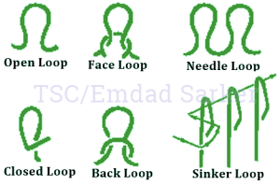
Face loop and technical face

Face loop:
During loop formation, when the new loop emerges through the old loop from back to the face side then it is termed as face loop or weft knitted loop.

Technical face:
The side of the fabric which contains all face loops or weft knit loops is known as technical face.
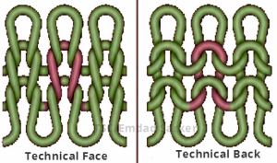

Back loop and Technical Back
Back loop:
During loop formation, when the new loop passes from the face side to the back of the previous loop then it is termed as back loop or purl loop.
Technical back:
The side of the fabric which contains all back loops or purl loops is known as technical back.

Knitted stitch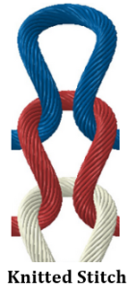
The knitted stitch is the basic unit of intermeshing. It usually consists of three or more intermeshed needle loops. The centre loop has been drawn through the head of the lower previously-formed loop and is, in turn, intermeshed through its head by the loop above it.

Stitch length
The length of yarn required to produce a complete knitted loop (i.e Needle loop and sinker loop) is known as stitch length or loop length.
Stitch length is a length of yarn which includes the needle loop and half the sinker loop on either side of it.
Generally, the larger the stitch length, the more extensible and lighter the fabric and the poorer the cover and bursting strength.

A course length
In weft knitted fabrics, a course of loops is composed of a single length of yarn termed a course length.
Definition: The length of yarn required to produce a complete knitted course is known as course length.
Course length= No. of loops per course X Stitch length
Course length= No. of needles X Stitch length

Stitch density
Stitch density refers to the total number of loops in a measured area of fabric.
It is the total number of needle loops in a given area (such as a square inch
Stitch density= Wales density x Courses density
=Wales per inch X Courses per inch
= WPI X CPI

Single jersey & Double jersey
Single jersey or plain fabric: The weft knitted fabric (Tubular/flat) which is produced by one set of needles.
Double jersey: The weft knitted fabric (Tubular/flat) which is produced by two sets of needles.

Fabric draw-off
The fabric loops are always drawn from the needles on the side remote from their hooks. When two sets of needles are employed, the fabric will be produced and drawn away in the gap between the two sets.
Needle bed or needle carrier
Needle bed or needle carrier is the place where the needles are located or mounted in a knitting machine. Needle moves up and down in the trick of a needle carrier.
Two types of needle carrier:
- Cylindrical or circular
- Flat
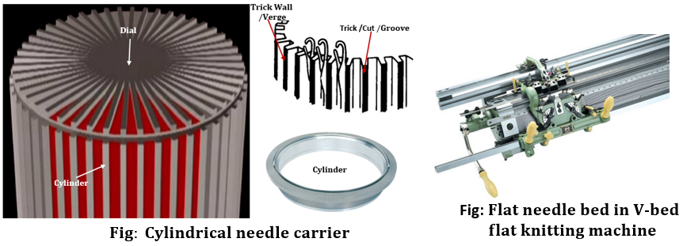

Cylinder and Dial

Cylinder:
Cylinder is a circular steel bed having grooves / tricks /cuts on it’s outer periphery into which the needles are mounted.
With reference to the tricks, the needles move vertically up and down by their butt being in contact with the cam track.
The diameter of the cylinder also varied based on the type and width of the fabric.
Maximum diameter of the cylinder: 46 inches.

Dial:
Dial is the upper steel bed used in double knit circular machines.
Into the grooves of the dial, the needles are mounted horizontally and are allowed to move radically in and out by their dial cams.
The number of grooves per unit space conforms with the cylinder gauge in most of the cases.
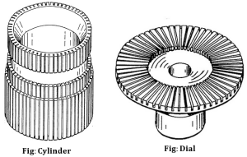

Machine gauge or Needle gauge
The number of needles present in one inch of a needle bed is called machine gauge. It is denoted by G or E.
Needle pitch:
The distance between two neighboring needles
Space required for each needle.
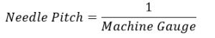

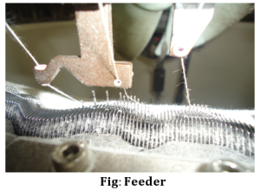
Feeder
Feeders are the yarn guides placed close to the needles to the full circumference of the knitting zone.
The feeders feed the yarn into the needle hooks and control the needle latches in their open position while the needle attain their clearing position.

