UNIT -2
Mechanical Finish:
Mechanical finishes – methods and applications;
Aesthetic finishes: Luster – glazed, moiré, schreiner, embossed;
Drape – crisp and transparent, burnt out, sizing, weighting;
Texture -sheared,brushed,embossed,plisse,pleated,flocked,embroidered,napped,fulled, and any two latest finishes.
Aesthetic finishes change the appearance and/or hand or drape of the fabrics.The appearance of fabrics is sometimes deceiving. In part, the appearance depends on the type of fibers, the construction of the yarns and fabrics, and the dyeing and printing involved. However, finishes can be applied to fabrics that enhance the basic aesthetic qualities. Aesthetic finishes influence the luster, texture, drapability,hand and surface appearance of fabrics as well as enhance a host of other qualities.
Techniques such as calendering, beetling, and burning-out influence the resulting appearance of the fabric. Permanent or temporary changes in surface pattern and luster of fabrics can be achieved through a variety of finishing techniques. Lustre finishes produces a change in fabrics light reflectance by making them more shiny.

LUSTURE:
Luster refers to the degree of light that is reflected from the surface of a fiber or the degree of gloss or sheen that the fiber possesses. The desirability of luster for a given fiber application will vary and is often dependent on the intended end use of the fiber in a fabric and on current fashion trends.
In textile fabrics lusture can be produced with the help of calendaring.
Calendering is a mechanical process that finishes fabrics by passing them between a series of rollers. By varying the rollers, adding any additional chemical treatment and/or temperature, a variety of calendered finishes result, including: glazed, ciré, embossed, Schreiner and moiré fabrics.
OBJECTIVE
To flatten the slubs
To decrease the air permeability
To give silk like appearance
To give luster or glaze to the fabric
To give soft and smooth surface to the fabric
MOIRE CALENDERING:
Moire is a textile with a wavy (watered) appearance produced mainly from silk, but also wool, cotton and rayon. The watered appearance is usually created by the finishing technique called calendering.
Attractive, lustrous wavy designs can be produced by a process that is essentially one of the minute surface embossing or pressing of a fabric with crenelled, or ridged rollers.
The best results are obtained on fabrics that have rib effect in the filling. The patterns is imprinted on the raised filling yarns by rollers, which exert over 100,000 pounds pressure to the square inch.
The luster is produced by the divergent reflection of light on the impressed lilies of the design.
Moireing technique:
The technique requires the fabric to be cut length wise in two. The matched halves are rolled tip on separate wooden rolls, or shell passed over a wavy ridged bar under considerable tension, and wound up together.
They are then put through a heavy, heated steel calender, and the patterns that have been induced in the goods by shifting the filling locally over the crenellated bar are embossed on the goods.
Patterned moire is done by passing the goods over a rubber roll engraved in relief with the pattern, while at the same time a brush engages the out side surface of the fabric and shifts the filling at the outlines of the engraving.
The width of the moire stripes is determined by the width of the crenellations in the bar used.
A moire pattern on a rayon fabrics is not permanent .
Silk holds the pattern longer but will gradually diminish. Dry cleaning is recommened.
On acetate, moire is definitely permanent because acetate fabrics have a melting reaction when subjected to the heat of the moreing process, thus conforming and hardening to the pattern as the cloth cools.
A similar condition can be obtained with nylon or other thermoplastic fiber because of its tendency to melt and to hold a shape.
An entirely different method of moireing cotton is obtained by treating the fabric with a chemical and then embossing the cloth.
The moire is permanent provided the fabric is cared for properly.
It should be washed with a mild soap or unbuild detergent in luke warm water and should never be bleached.
Uses
In personal fashion, moire is most often now used for silk taffeta evening wear and ballgowns. It’s also frequently used for home furnishing fabrics, such as drapes and upholstery, usually in formal rooms. You may also see a moire fabric lining a jewelry box or a purse.
Care
Moire fabrics usually have a good amount of body and may even be stiff, but great care should be taken in folding them as they can retain creases, and most cannot be steamed or ironed. Some also lose their special luster if they get wet, so many items made with a moire pattern--especially silks and rayons--must be dry cleaned.
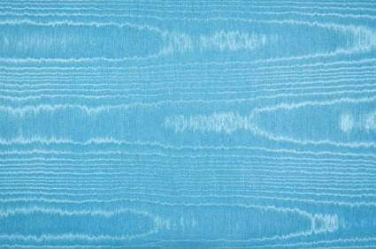
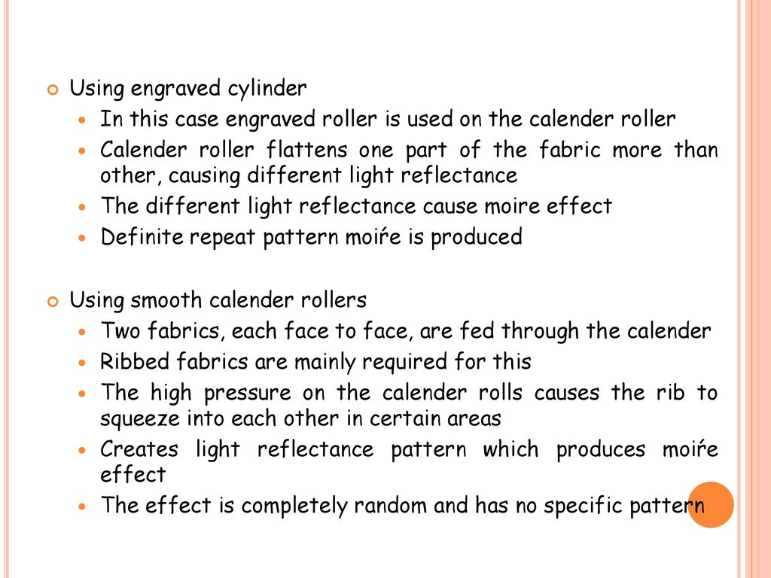
SCHREINER CALENDER
This is a special calender invented by schreiner in 1895.
It produces a beautiful silk like lustre on cotton fabric by embossing fine lines on it and is therefore also known as “SILK FINISH”.
The process is based on the principle that the lustre of fabric is greatly increased if all the individual fibres appearing on the surface are aligned parallel to each other.
This is achieved by embossing the surface of the fabric with parallel lines spaced at a distance equal to or nearly equal to the thickness of the cotton fibre.
Engraving of 50 to 200 lines per cm are made on highly polished metallic bowl; the lines are not too deep and sharp other wise they may cut the fibres and weaken the fabric.
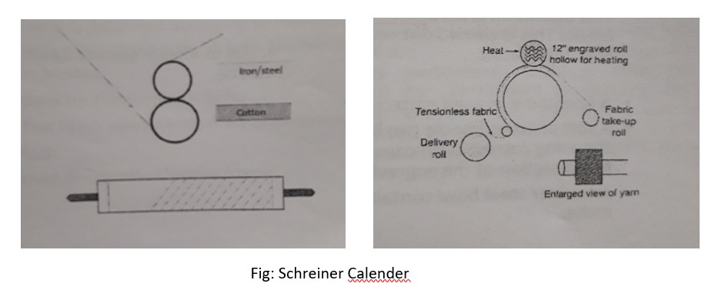
The usual schreiner calender consists of two bowls; the upper bowl is made of special steel the surface of which is highly polished and is engraved with the parallel lines.
The lower bowl is of compressed paper. The metal bowl is heated by gas usually to 150c.
The two bowls are in contact with each other when the machine is running and are separated when not in use.
Very high pressure of 100 ton and more is exerted on the fabric when it passes through the nip. The lower bowl in some cases is set at an angle by skewing arrangement to give enhanced brilliancy to the cloth.
Cotton fabric before passing through the nip is suitably conditioned it is generally singed, mercerised and dyed and then damped .
Mercerised fabric when treated on this calender gives a silk finish.
A three bowl schrenier calender is used where large output is required. In this the engraved bowl is in the middle and the other two bowls are of compressed paper, the fabrics are passed through the upper and lower nips simultaneously.
The spun glass finished is produced by schreinerig and at the same time friction calendering.
Like other calender finishes schrenier finish is also temporary the impression of the fine lines is destroyed when thr fabric gets swollen with water. Most schreinered material is, there fore used for linings which are not washed.
A large amount of schreinering is done on goods dyed with aniline black.
Embossing Calendaring
Embossing is a particular calendaring process through which a simple pattern can be engraved on the cloth. The machine is made up of a heated and embossed roller made of steel pressed against another roller coated with paper or cotton. Its circumference is precisely a whole multiple of the metal roller. A gear system operates the coordinated motion of the rollers, preventing them from sliding and granting a sharp engraving of the patterned design. After being engraved, the pattern can be stabilized using appropriate high-temperature treatment or applying suitable starchy substances.
A typical three bowl embossing calender consists of a middle engraved steel bowl and top and bottom bowls of cotton having the same diameter which is 3 times that of the metal bowl.
The steel bowl may be 20cm in diameter when the cotton bowl will be 60cm in diameter. This is done to ensure repeat of the design and to prevent crushing.
The bowl can be seperated when the machine is idle. The metal bowl is heated and pressure is applied by lever and weights. The cloth is dampened before embossing
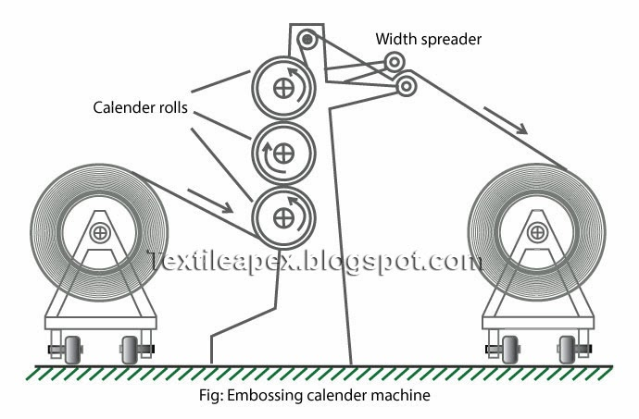
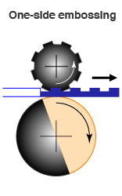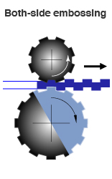
The process can be applied to fabrics made of all types of fibres, except wool. This finish is permanent when applied to fabrics made of thermoplastic fibres. It is not permanent when applied to untreated fabrics made of natural fibres or artificial fibres that are not thermoplastic; however, if these fabrics are treated with specific chemical resins, the embossing is considered pretreatment.
To preserve the embossed finish of such fabrics, they should be washed in lukewarm water with a mild soap, never be bleached, and be ironed on the wrong side while damp.
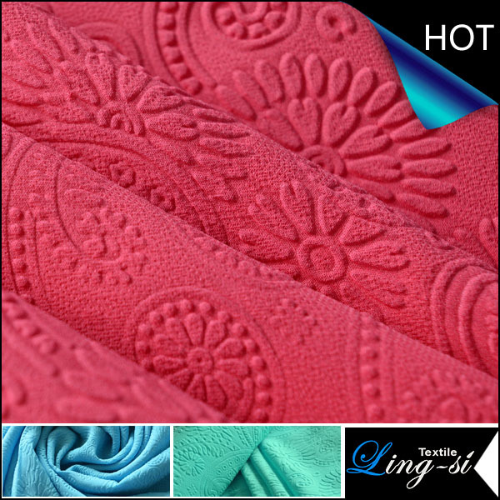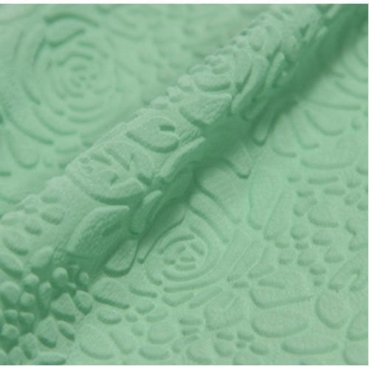
Advantages
Crepes or pebble effect can be produced.
Temporary and permanent effect may be produced by different of pressure and heat.
Due to smaller metallic bowl, cost is less.
Generally used for synthetic fabrics. It cannot create any effect on cotton fabric.
FELT CALENDER
Light weight cotton goods like super fine Dhoties Sarees,Rolles etc., are finished on this method.
This is also employed for the finishing of knitted goods.
Blanket drying is a special method of cylinder drying. Here the cylinder is used for both drying and finishing.
The main cylinder is 6 to 8 feet in diameter made up of tinned sheet Iron or Stainless steel.
The cylinder is heated by steam and rotates freely.
An endless woollen felt blanket passes around the major part of the cylinder.
The cylinder is rotated along with the endless blanket.
Before feeding the fabric to this machine, the fabric is passed through a padding mangle for applying the finishing mixture and then passed over an expander or a small stenter .
Then the fabric is fed between the blanket and the cylinder and is kept against the hot surface by the pressure of the blanket during drying.
In this manner, there is no undue tension on warp.
In addition to drying it gives an attractive finish with soft feel and a smooth surface.
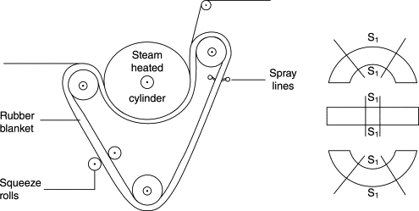
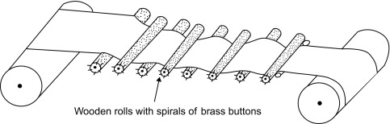
In another type of felt finish, the fabric is finished on hot air stenter, damped on a damping machhine and then passed through felt calender to get required feel.
Speed of this machine is 30 to 40 mts/min.
Fabric width of 1 to 2.5 cm can be reduced by this machine.
DRAPE – crisp and transparent, burnt out, sizing, weighting
WHAT IS DRAPE?
Drape is the ability of a fabric to fall under its own weight into wavy folds of different nature. It is an important property of textile materials which allows fabric into a graceful folds or pleats. A fabric is said to possess good drape ability when its configuration is pleasant to the eye.
Add a chemical compound to the fabric (Additive finish) or dissolve the portion of the fibres ( Subtractive finish) for increasing drape in a fabric.
Importance of drape in garments
Used to add flare and fullness so as to create different drape effects
according to changing fashion trends, and changing demands of consumers
- obtained by the use of pleats, gathers, tucks, seam flare, angular panels etc.
- It also depends upon grain line and cut of the fabric.
Finishing agents may be used to alter stiffness of the fabric.
FACTORS AFFECTING DRAPE OF FABRIC
Drapeability of a fabric is combined effect of several factors such as stiffness, flexural rigidity, weight, thickness etc.
Stiffness, is one of the most important factors determining draping quality of fabric
e.g. soft fabric drapes closer to the body forming ripples whereas stiff fabric drapes away from the body.
The draping quality of fabric is affected by the stiffness of the fiber and the yarn, the size of yarn, thread count and method of construction.
The handle of cotton fiber is hard and stiff whereas wool has soft to medium handle. The handle of polyester is medium to hard.
Yarn stiffness is controlled by fiber stiffness and also by arrangement of fibers in yarn.
Highly twisted yarns make fabric stiffer.
Fabrics made from heavy, coarse yarn and in dense construction do not drape well. Fabrics that have long floats in weave can be more flexible, bending more easily and improving draping quality.
If at the same time, fabrics are made from filament yarns with little twist, the draping quality is enhanced more. Drape ratio of woven and nonwoven fabrics differ because of the difference in their method of construction.
Finishing agents can be used to alter fabric hand and change draping quality. Starching gives body, weight, smoothness and stiffness to fabric.
CRISP AND TRANSPARENT:
Parchmentising is a textile finishing treatment for cellulose fabric, mainly cotton and flax, which stiffens the fabric and imparts a degree of translucency.
Transparent or parchment effect cotton fabrics are produced by treatment with sulphuric acid.
The fabric may then be referred to as parchmentized. Since acid dissolves cotton , this process must be very carefully controlled. Split – second timing is necessary to prevent tendering of the fabric.
Several effects are possible an all over, a localized, Or a plisse effect.
here are two types of parchmentization finishes
All over: A crisp and transparent fabric called organdy is produced with this finish. Sheer lawn fabric is singed, desized, bleached, mercerized and dyed with colors that resist acid damage.
Then it is immersed in acid solution for a split second and dried. Cotton dissolves on exposure to acid and hardens as a cellulosic film upon drying.
This finish imparts crispness and makes the fabric transparent. The cloth is later neutralized in an alkali, washed and calendered.
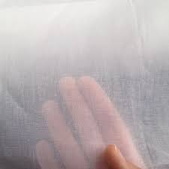
Localised parchmendising:
The fabric is printed in the form of a design with an acid resist material. Later it is immersed in an acid solution. This produces both opaque and transparent areas. The acid resist area remains opaque while the rest of the fabric becomes transparent on acid exposure.
If a small design is desired the acid is printed on in a paste form and then quickly washed off.
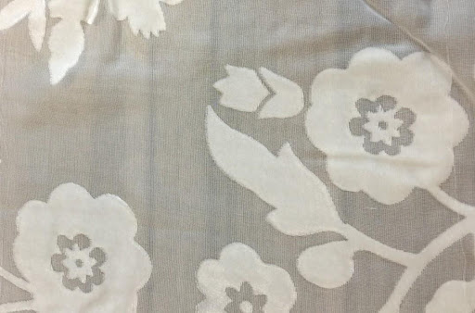
Burnt out and etched effects:
Blended fabrics like rayon and polyester are more suitable for producing burnt out effects. A chemical usually an acid is printed in the form a design, which then dissolves one fibre leaving the area transparent and other areas opaque. They are also known as etched fabrics. This is an example of subtractive finish as a part of the fabric is dissolved.
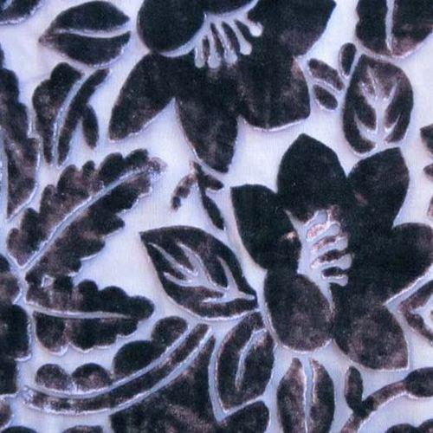
WEIGHTING OF SILK
SILK DEGUMMING:
“The process of removing the sericin or silk gum from silk fibre is called degumming”.
The fibroin present in the silk fibre is covered by thin layer of sericin.
This sericin present in the silk fibres greatly affects the handle, sheen and texture of the finished goods,
It gets necessary to remove the sericin from the silk fibres.
The silk gets more soft, lustrous after removal of sericin.
During degumming process, the yarn or fabric is treated with an alkaline ( sodium carbonate) and surfacing agent( sodium lauryl sulphate) .
The required chemicals are dissolved in normal water.
Some amount of hot water is added to it for proper dissolution of chemicals.
Now the yarn or fabric is treated with this solution for 30 minutes. The silk is washed with hot water.
Then it is neutralized with citric acid or any other suitable neutralizing agent(acid).
There almost 15℅ to 25 % weight loss occurs after complete removal of sericin during degumming of silk.
SILK WEIGHTING PROCESS:
" The process of recovery of weight loss during degumming by using any external weighting agent is called weighting of silk".
soaking the fibre in a bath of these metallic salts. This process was called weighting, Weighting with some metallic salts did improve the drape ability of the fibre.
There are 3 methods which are followed:
1st method:
The silk is soaked with stannic chloride solution followed by fixation with sodium carbonate followed soaping.
Marginal weight increase is observed but the pull is too adversely affected in this method.
2nd method:
- The silk is soaked with stannic chloride and fixed with sodium phosphate.
- It is then washed and treated with little amount of sulphuric acid.
- It is then soured, washed taken out.
Even though increase in weight is considerable, the strength loss is still high in this method.
3rd method:
- In this method the fixation is done with sodium silicate.
- This brings out the required increase inwards weight without affecting the strength much.
COMMERCIAL METHOD:
- In the normal practice, silk is soaked in stannic chloride solution called Picking.
- Later it is treated with sodium phosphate called Phosphating.
- The picking and Phosphating is carried out alternatively till the sufficient weight is achieved and the sequence is:
- Picking - washing - Phosphating - acidifying
- Finally after sufficient loading, it is treated with Sodium Silicate.
SIZING:
Sizing is an intermediate protective process which is done to prepare the yarn for the weaving process. The process of applying a protective adhesive (synthetic/ natural) coating upon the yarns surface is called sizing.
- It also maintains good fabric quality by reducing hairiness, weakness & by increasing smoothness, absorbency of yarn. The most other features of the sizing is change of various physical properties.
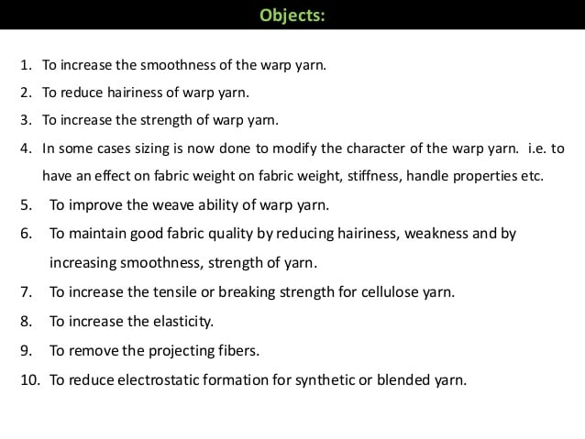
Different Techniques Of Sizing
Hot melt sizing.
Solvent sizing.
Foam sizing.
High-pressure sizing.
Electrostatic sizing.
Emulsion sizing.
Combined sizing.
Conventional sizing.
Sizing Machines
The sizing process consists of impregnating with the size the warp unwound from the warping beams, drying, separating the ends and beaming. Moreover, during the sizing process, the warp is marked for dividing it into pieces of predetermined length.
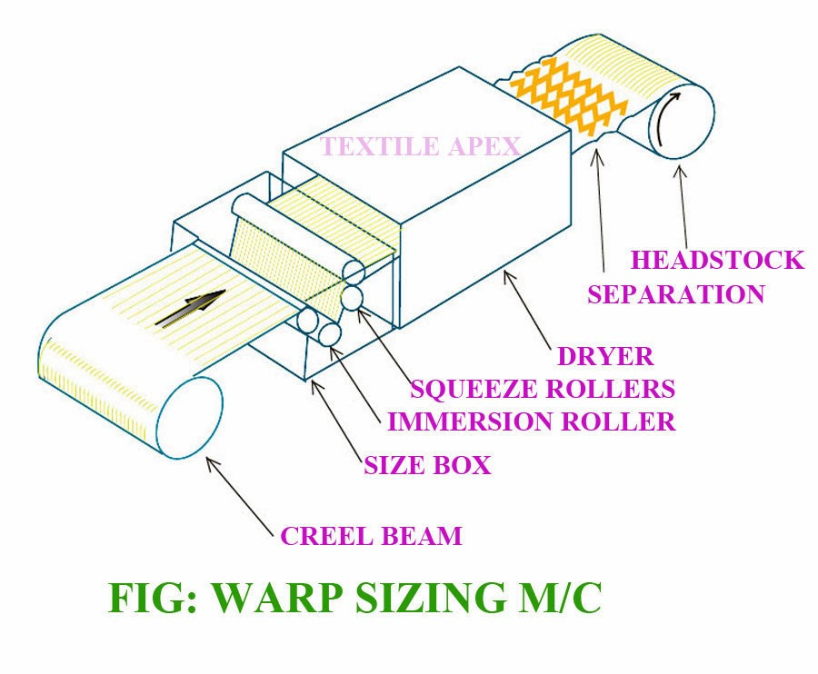
The main parts of a sizing machine are the creel for the accommodation of the warping beams; the sizing unit consisting of a size box and immersion and squeezing rollers; the drying section where the excess moisture is removed from the size and pressed warp ends; the headstock.
A particular device is also provided therein for additional treatment, i.e. emulsification and waxing of sized warp, and automatic instruments for checking the sizing process.
Depending upon the arrangement of the drying section, all sizing machines may be classified as follows:
Cylinder sizing machine – in which the warp is dried by contact with the hot surface of the cylinder;
Hot air sizing machine – in which drying is effected in chambers with hot air;
Combined sizing machine – in which the warp is dried by contact with the hot surface of the cylinders and bypassing through hot air chambers;
Special sizing machine - in which the warp is dried by electric heating, high-frequency currents, by infra-red rays etc.
Types of Sizing:
Pure sizing: when the size pick up % is about 3 – 10 % it is called pure sizing.
Light sizing: when the size pick up % is about 11 -16% it is called light sizing.
Medium sizing: when the size pick up % is about 17 – 40 % it is called medium sizing.
Heavy sizing: when the size pick up % is above 40 % then it is called heavy sizing.
TYPES OF SIZING:
Temporary Stiffening
- Fabrics, particularly cotton and linen, are given a temporary stability and stiffness by application of a firming agent which is often a solution of starch.
- It is commonly known as 'starching' or 'temporary stiffening'.
- When this process is done while preparing warp for weaving, it is called 'sizing' and 'dressing'.
- The term 'dressing' is generally used for the warp of wool.
- Other than starch, the substances used for stiffening fabrics are flour, dextrine, glue, shellac, fats, wax, and paraffin.
- Sometimes clay, chalk, barium sulfate, calcium sulfate or magnesium sulfate are also used for stiffening cotton fabrics.
- At times back starching is also done in which only the back side of the fabric is starched.
- Temporary stiffening is required to retain the freshness of the fabric till it is not used for making any product.
- Stiffening also allows the fabric to be cut more easily into patterns for the textile products.
Permanent Stiffening
- The fabrics which are permanently stiffened usually need less laundering and therefore become more durable.
- Permanent Stiffening is done by chemical processes that change the cellular structure of the fiber.
- This process makes the fabric smoother and dirt resistant as the dirt tends to slide off rather than cling onto the fabric.
- Some of the permanent finishes are Ankord, Basco, Clearight, Kandarized, Saylerizing, Sheercroft, Staze- Right and Turbenizing.
- They all give the fabric such properties as tensile strength, luster, shrinkage resistance, crispness, abrasion resistance and improve the appearance of the fabrics.
- Turbenizing is done to avoid the need of starching fabric for its life.
- This can be done through three methods.
- The parts to be stiffened like collar, cuffs, belts are interlined with a thermoplastic fiber or with cellulose acetate or the fabric my be coated with synthetic resin.
- The thermoplastic fibers melt and bonds with the garment when pressed with a hot iron producing a stiffened fabric.
- When cellulose acetate is used, it is softened by acetone which is also heat pressed on to the fabric giving permanent stiffness.
- A coating of resin is also heat pressed on to the fabric.

TEXTURE -SHEARED,BRUSHED,EMBOSSED,PLISSE,PLEATED,FLOCKED,EMBROIDERED,NAPPED,FULLED, AND ANY TWO LATEST FINISHES.
TEXTURE EFFECT
Texture refers to the physical surface of a piece of cloth. Sometimes it has a visible unevenness and sometimes it appears completely smooth. The weave and the size and quality of thread used in it affect the texture of the finished cloth.
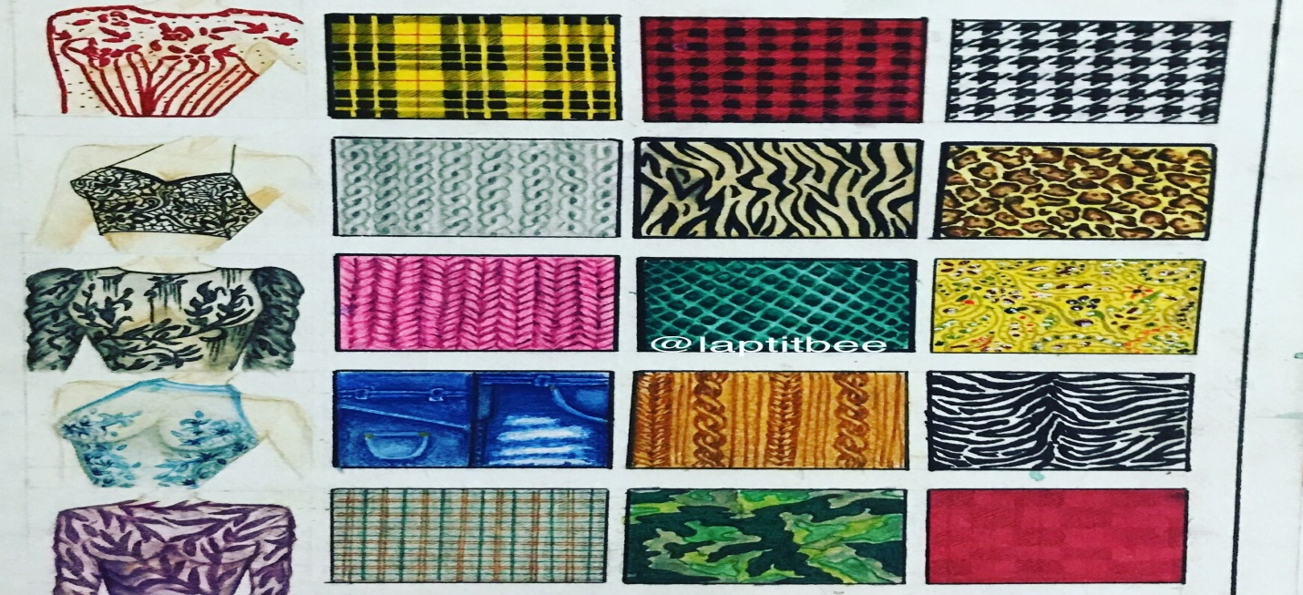
SHEARING
Shearing, in textile manufacturing, the cutting of the raised nap of a pile fabric to a uniform height to enhance appearance. ... Shearing may also be applied to create stripes and other patterns by varying surface height.
Generally shearing is applicable to nap and pile fabrics in order to remove the irregularities in pulled yarn ends, knots and other surface flaws and to lay the nap or pile evenly on the surface of the fabrics.
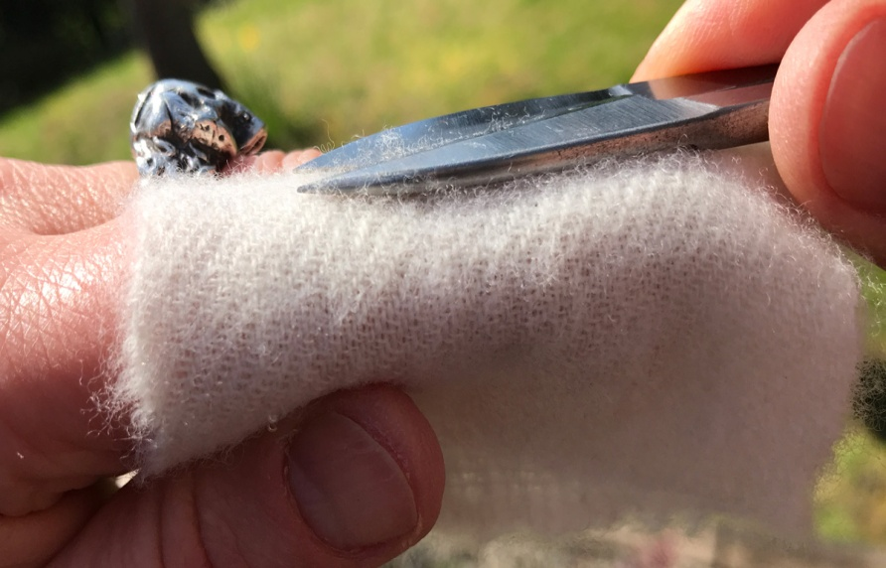
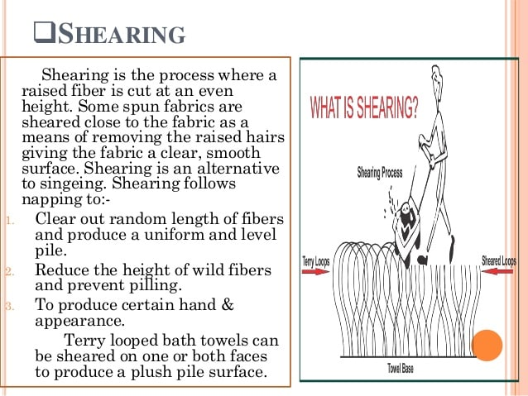
PROCESS:
Before shearing, the fabric is passed over brushes that raise the fibre ends/yarn ends. Then it will be passed under the cutting blades which shear the pile/nap. Adjustments can be made to cut the pile as per the desired depth.
Shearing is carried out with the help of wide spiral cylinder that contains cutting blades diagonally. The working principle in shearing is just like a lawn mower.
The shearing unit is composed of two sharpened elements, that are working is a similar way to a scissors.
The first element is a roller, with a certain number of blades (usually from 10 to 24 but can be less or more) fixed on it with an helical displacement, this roller is rolling on a flat blade; the contact between the helical blades and the ledger blade is giving the cutting function.
The rotation of the shearing roller on the flat blade, creates a continuous cutting effect and the point where the flat blade and the helical blades meet, is called the cutting point.
The fibers cut by the cutting operation are removed by a vacuum system, composed of a suction box, placed in the back of the shearing roller
The fabric is brought in the cutting point by the cutting stand, the cutting stand may have different shapes according to the kind of fabric to process.
The distance between the cutting point and the cutting stand is called shearing height, and it is the height that the ensemble of fabric and pile, will have after shearing.
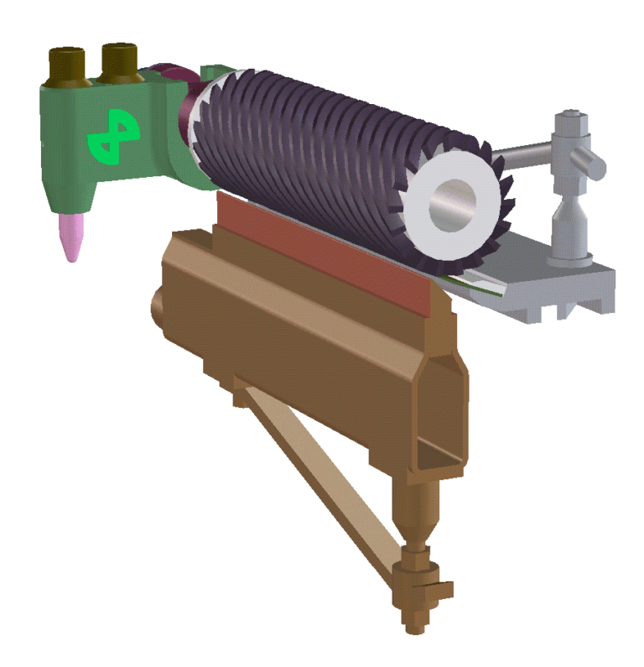
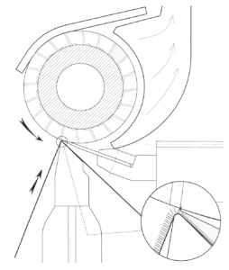
BRUSHING
Short loose fibres on the surface of the fabric can effectively be removed by brushing the surface of the fabrics. In case of nap and pile fabrics, brushing is carried out before shearing to help in laying the nap/pile at desired depth.
Brushing is carried out by cylinders covered with bristles that raise the fibre/yarn ends and remove the loose fibre. Light brushing is done to spun yarn fabrics before singeing, so that the fabric will be smooth for further process.
Brushing system contains a pair of brush rolls to remove the dust and impurities to clean the fabric.
Beaters can also be provided with the same system
Tension mechanism is provided with guide rolls to increase the brushing intensity
High Pressure Suction & Dust Collector Device is attached to the systems
Compact design of the systems allows to fit the system on various existing machines on site.
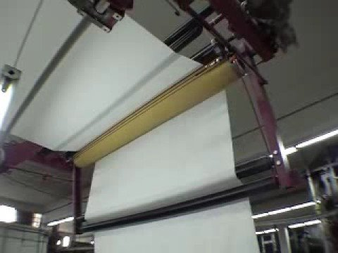
EMBOSS FINISH:
Textile embossing is generally done on smooth surfaces. This is done by pressing the fabric under high pressure, and at high temperature, in a special backing creating a three dimensional effect giving a unique look to the garment.
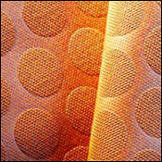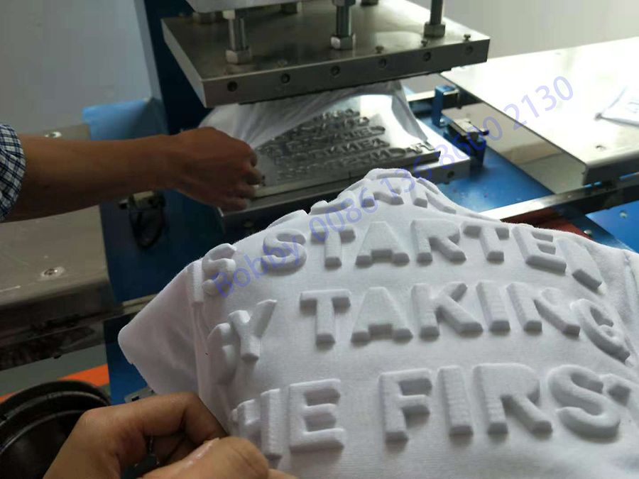
Types of Embossing:
- Blind Emboss: in which the embossed image and the fabric surface are the same.
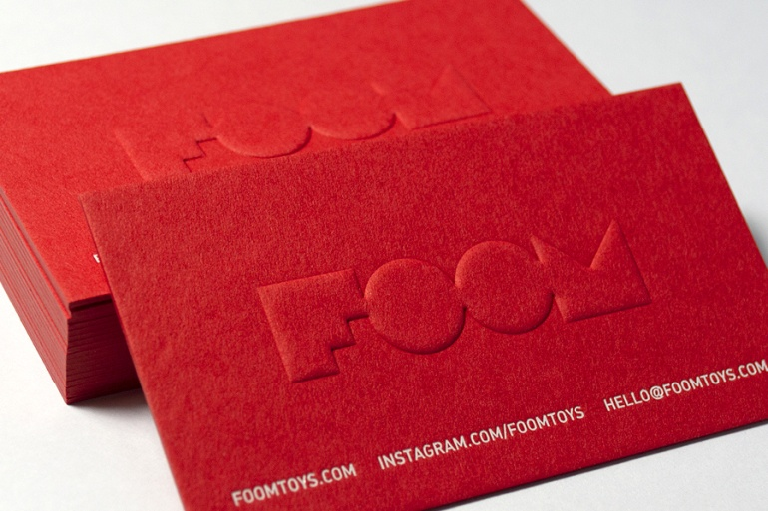
- Tint Emboss: Here a pastel foil or pearl is used. This is much in demand currently.
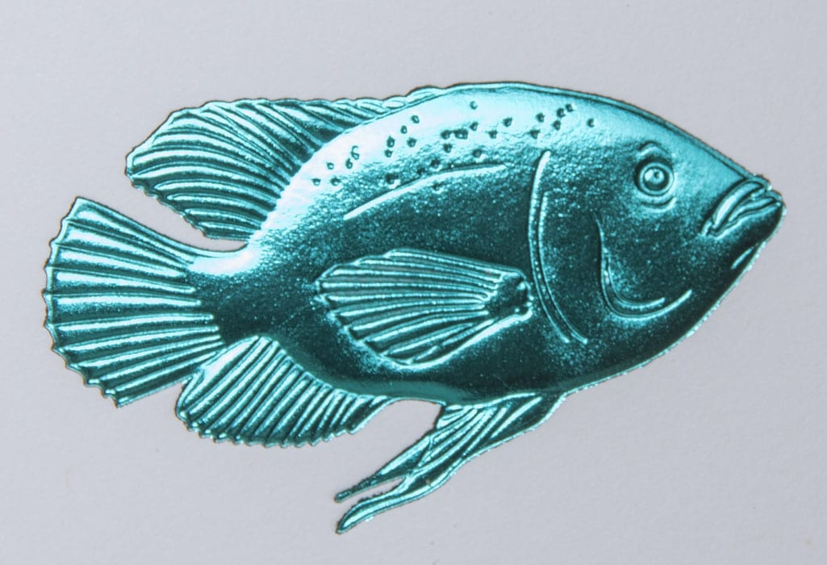
- Single Level Emboss: where the image area is raised to one flat level.
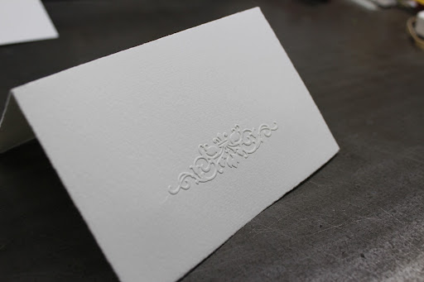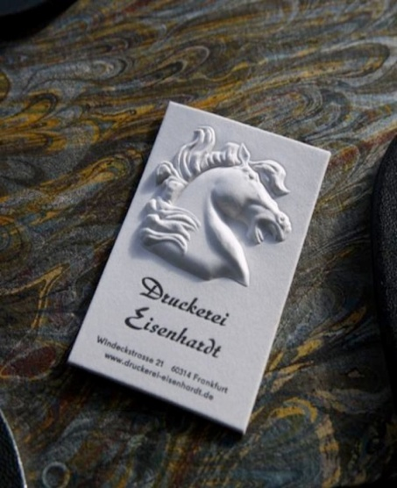
- Multi Level Emboss: in which the embossed image is raised to different levels to give a depth to the embossing.
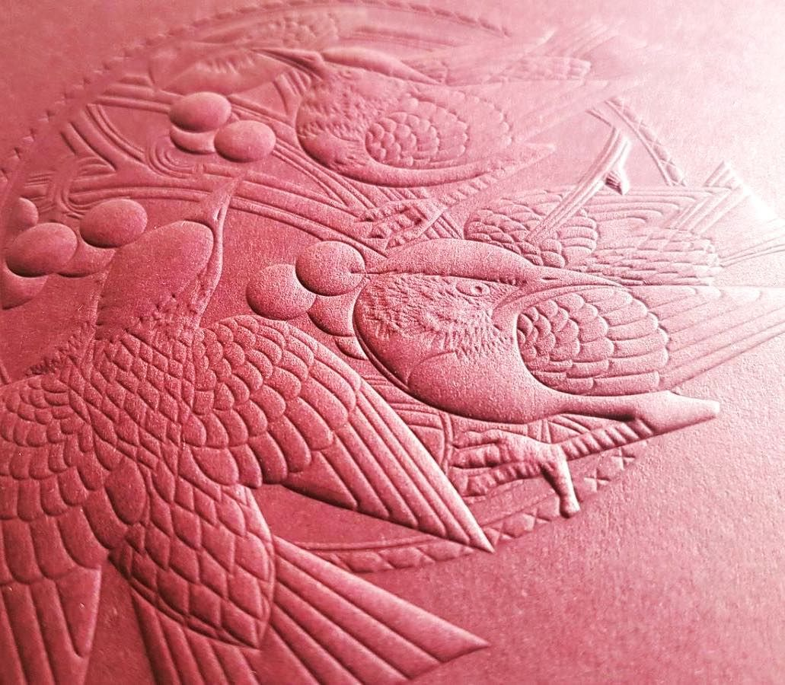
- Printed Emboss: where the embossed part registers with a printed image.
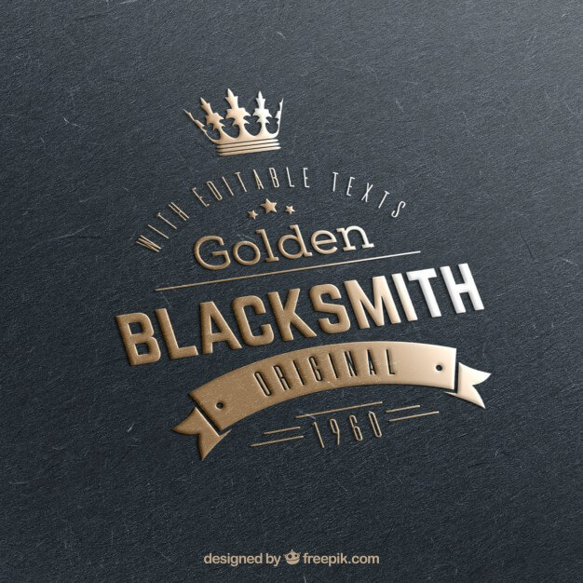
- Registered Emboss: where the printed image is embossed to give a raised look.
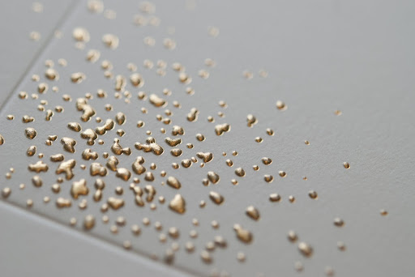
- Glazing: This is a polished emboss used on dark colored surface. More heat and pressure is applied during embossing which give a shine to the fabric surface. This method is most commonly used for contrasting designs.
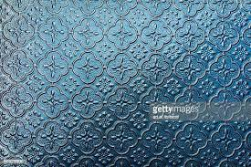
Embossing Calendaring
Embossing is a particular calendaring process through which a simple pattern can be engraved on the cloth. The machine is made up of a heated and embossed roller made of steel pressed against another roller coated with paper or cotton.
Its circumference is precisely a whole multiple of the metal roller. A gear system operates the coordinated motion of the rollers, preventing them from sliding and granting a sharp engraving of the patterned design.
After being engraved, the pattern can be stabilized using appropriate high-temperature treatment or applying suitable starchy substances.
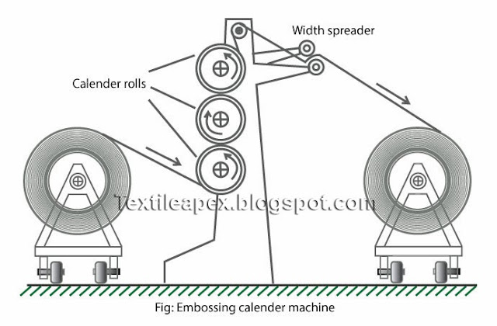
The process can be applied to fabrics made of all types of fibres, except wool. This finish is permanent when applied to fabrics made of thermoplastic fibres.
It is not permanent when applied to untreated fabrics made of natural fibres or artificial fibres that are not thermoplastic; however, if these fabrics are treated with specific chemical resins, the embossing is considered pretreatment.
To preserve the embossed finish of such fabrics, they should be washed in lukewarm water with a mild soap, never be bleached, and be ironed on the wrong side while damp.
PLISSE EFFECT
Puckering fabric by adding a chemical that causes them to shrink. ...
A lightweight, plain weave, fabric, made from cotton, rayon, or acetate, and characterized by a puckered striped effect, usually in the warp direction.
The plisse prints are created by application of strong alkali to 100% cotton fabric. The alkali is applied in a pattern. After some time ( usually several minutes) the fabric is washed so that the alkali is removed. This results in the shrinkage of fabric from those areas where alkali is applied. This shrinkage causes puckering in the areas where alkali is not applied. A seersucker type appearance can be given to the fabric by applying the print pattern in parallel stripes. The alkali can be applied using direct or resist methods.
End- uses include dresses, shirtings, pyjamas, and bedspreads.
Cotton, rayon, and other fabrics that have been treated with a caustic soda solution which shrinks parts of the goods either all over or in stripes giving a blistered effect that is similar to seersucker in appearance.
Produced by a wet finishing treatment, this fabric has the look of woven seersucker, similar to crepe. This crinkle may or may not be removed after washing.
This depends on the quality of the fabric. It does not need to be ironed, but if a double thickness, such as a hem, needs a little, it should be done after the fabric is thoroughly dry.
A Fabric With A Puckered Effect Resulting From Printing The Fabric With Caustic Soda . The Printed Part Of The Fabric Shrinks, Causing The Unprinted Part To Pucker.
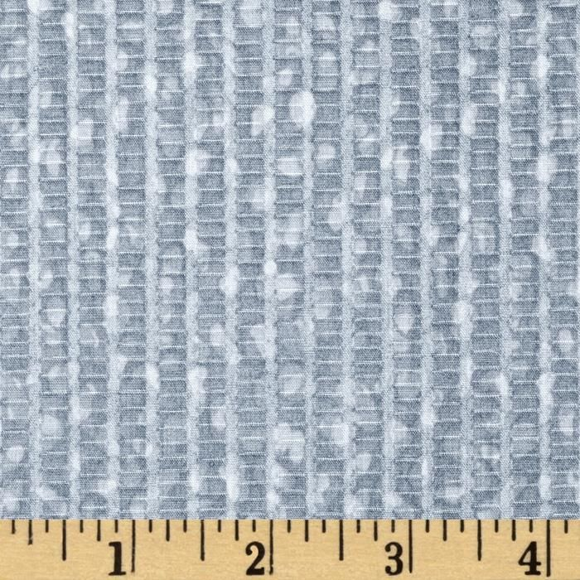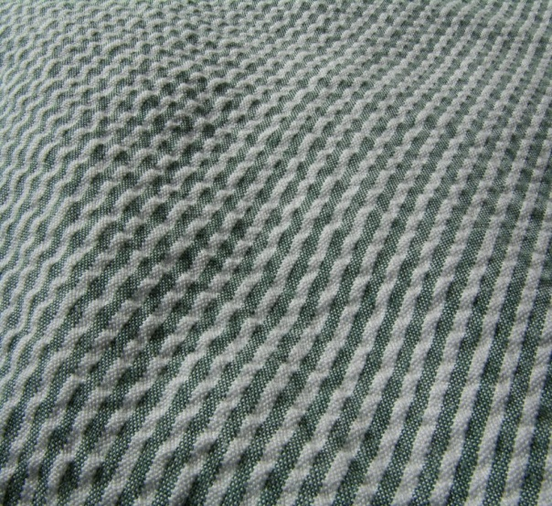

PLEATED EFFECT
PLEATING
- A mechanical finish combined with a thermal or chemical process to make the finish permanent.
- The size and shape of pleats range from simple knife or box pleats to novelty scalloped pleats to random pleated designs.
- The method for pleating depends on factors such as fabric, desired look and fiber content
Introduction of permanent creases.
- A pleated fabric is made using a variation of embossing.
- Pleating is a highly specialized operation done by either the paper pattern technique or by the machine process.
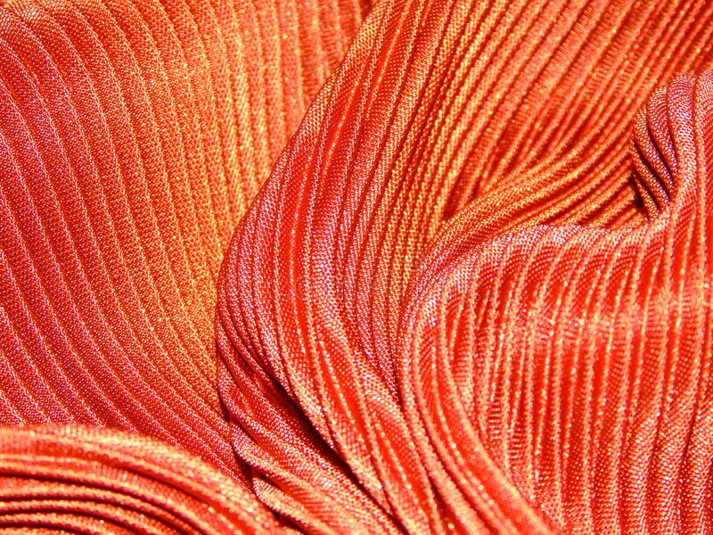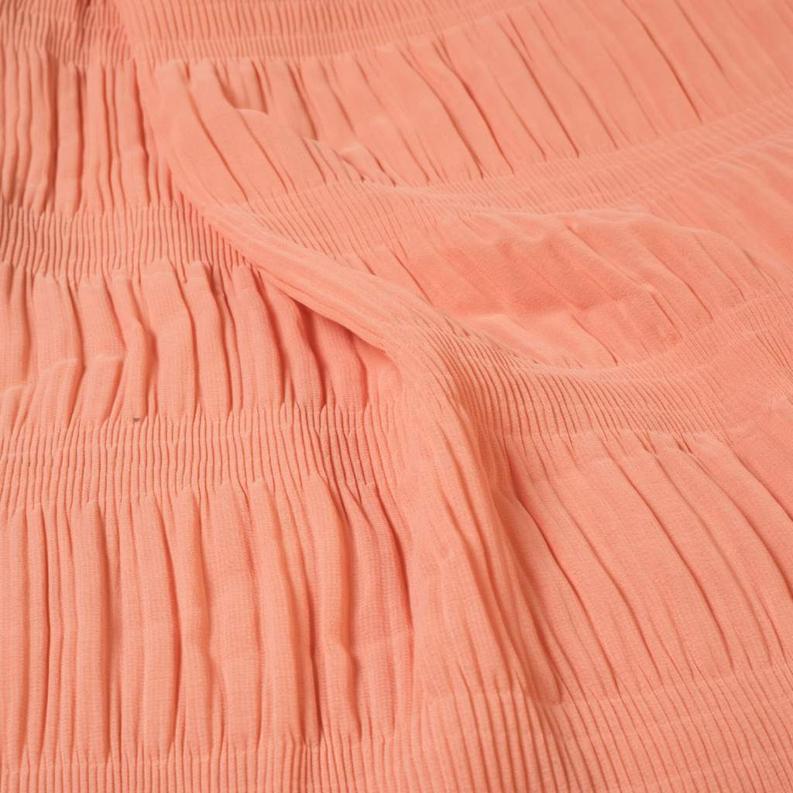
Pleating is done on fabric in two ways
- Hand pleating
- Chemical pleating/Machine pleating
- Hand pleating
- just stitch the fabric in pleats as you need, pleated either randomly or in a regular pattern- the way we sewists do it.
- Chemical pleating/Machine pleating – The alternative way is how the pre-pleated fabrics are made either using chemicals to pleat the fabric or using heat and pressure with specialized machinery that folds and creases and sets the pleats at the same time. The fabric is pleated using pressurized steam and heat.
Heat and pressure used with specialized equipment is the preferred way of making pre pleated fabrics today. Pleats made this way are very durable.
The machine pleating process is very expensive. High precision blades heat the fabric as it is inserted between two heated rolls in the machine. A paper backing is used under the pleated fabric, and paper tape holds the pleat in its place. After leaving the heated roll machine the pleats are set in an ageing unit. Stitching the pleats in its place produces permanent three dimensional effects in apparel, upholstery ,wall coverings, window treatments, and lamp shades.
PAPER PATTERN TECHNIQUE
This is a costly hand process, but it produces a wider variety of pleated designs. Partially completed garment components, such as hemmer skirt panels are placed in a pattern mold by hand.
Another pattern mold is placed on top so that the fabric is pleated between the pleating papers. The three layers are rolled into a cone shape, sealed, and heat set in a curing oven.
Types of fabric suitable for Chemical pleating:
Polyester is the favourite for making the pre-pleated fabric. On polyester, the pleats formed remain the same for the life of the fabric.
The soft, smooth and lightweight and flowy nature of polyester fabrics, especially polyester chiffon fabrics makes it a popular choice in dressmaking.
Other best fabrics preferred for pleating are silk and wool.
Chemicals are used on natural fabrics like cotton and silk for pleating them.
Thin and Lightweight fabrics like silk georgette silk taffeta, silk organza, china silk and cotton voile etc are used for pleating. Along with chemicals, heat and pressure are also used as per requirement.
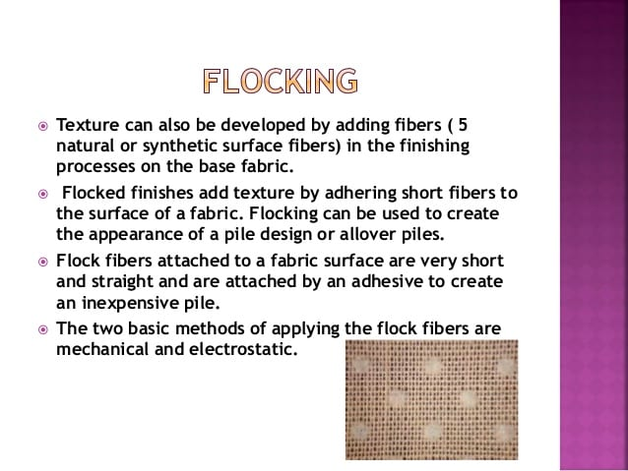
Flocking is usually applied by the high-voltage electric field.
Flocking is an inexpensive method of producing an imitation extra-yarn fabric, flocked in a design, or a pile-like fabric where the flock has an overall pattern.
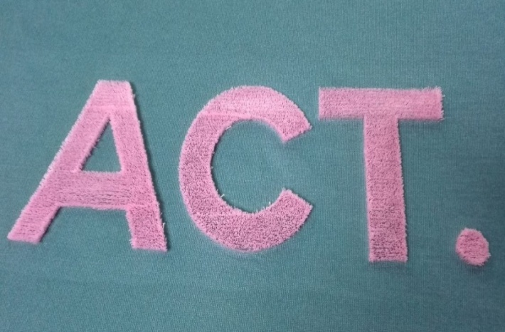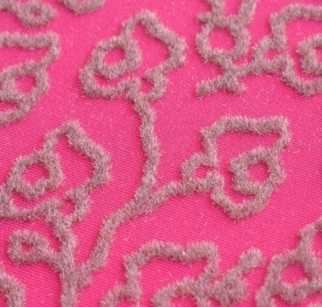

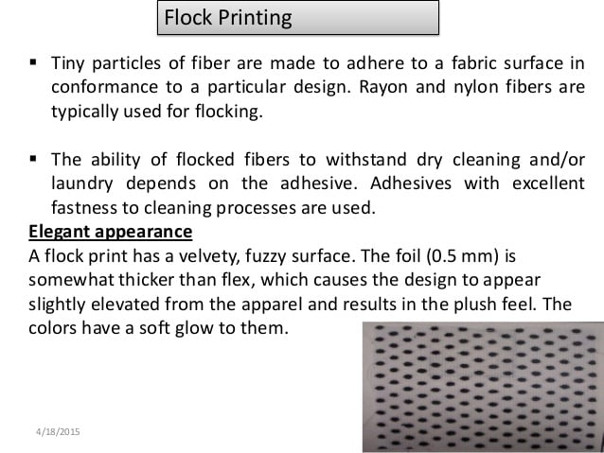

Flock material flies vertically onto the substrate attaching to previously applied glue. A number of different substrates can be flocked including textiles, fabric, woven fabric, paper, PVC, sponge, toys, and automotive plastic.
The majority of flocking done worldwide uses finely cut natural or synthetic fibers. A flocked finish imparts a decorative and/or functional characteristic to the surface.
Mechanical fiber-coating on flat surfaces is usually achieved using the beater-bar method. This technique involves the passage of an adhesive coated substrate over a series of polygonal rollers that rapidly rotate to vibrate the substrate. The vibration is used to drive the fiber into the adhesive. Fibers are applied by gravity onto the substrate.
Pneumatic flocking applies flock in a directed airstream. This method is most commonly used to coat three dimensional objects such as automotive glove boxes.
In mechanical flocking most unit consists of 6 to 20 beater bars and one or more sifting hoppers and operate at 10 or more yards per minute.
Simpler in design, usually less expensive, and most widely used in the united states.
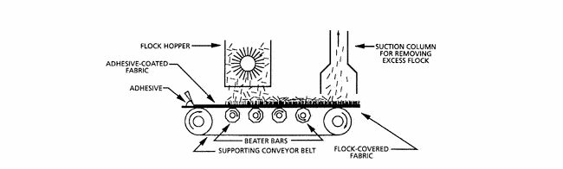
Electrostatic flocking utilizes an electric charge to orient fibers and promote their perpendicular alignment. ... The charged fibers become aligned with the electric field lines of force and are attracted to the grounded electrode. The flock moves towards the adhesive coated substrate and becomes embedded.
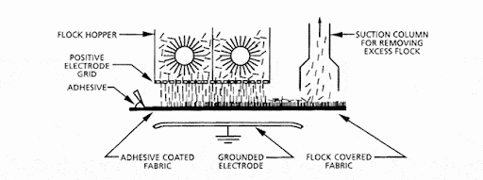
Most units operate at speed of 3-5 yards per minute.
Can apply fibres to both sides of the fabric.
Gives end on end fibre orientation . Higher densities are possible.
Rayon fibres are in expensive and easy to cut, and are used in large quatities for wall coverings, toys, and garments.
Cottons is used in packaging and greeting cards.
Nylon for upholstery and blankets, has excellent abrasion resistance and durability.
Acrylics, polyester, and olefins also are used for weatherstripping, sealing applications, and automotive squeak
NAPPING
Raising or Napping: A finishing process that raises the surface fibers of a fabric by means of passage over rapidly revolving cylinders covered with metal points or teasel burrs. Napping is a process that may be applied to woollens, cottons, spun silks, and spun rayons, including both woven and knitted types, to raise a velvety, soft surface.
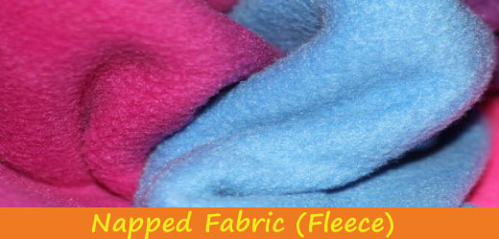
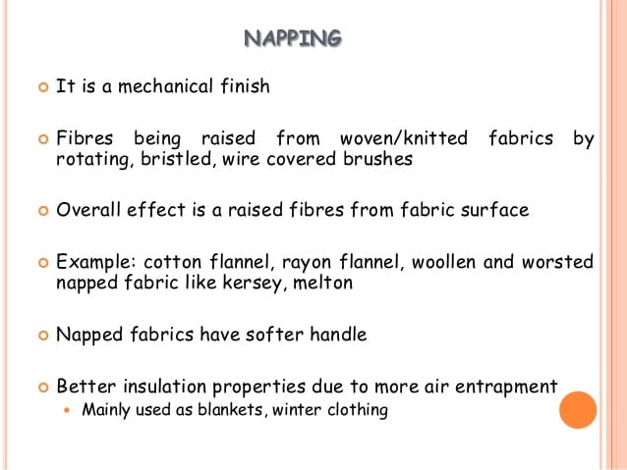
MACHINES:
Raising machines are generally two types
- Teasel machine
- Hard wire machine
TEASEL MACHINE
Teasel are obtained from a particular type of plant. These are throny bristles which are fitted on bars and such bars are fitted horizontally on a large drum.
The cloth passes in contract with the drum carrying the tessels in the same direction but at a slightly lower speed than the drum, with the result of that the fibres are raised up. It is better to moist slightly the fabric to ensure raising as dry raising has the defect of tearing the fibres.
In this process the cover or pile is raised in one direction only.
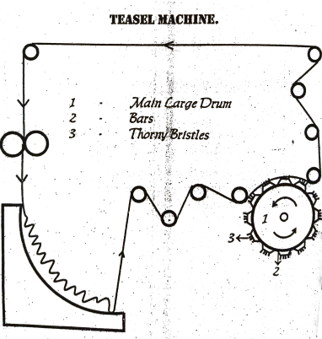
CARD WIRE RAISING MACHINE
Card wire raising machines are usually constructed on the basis of a cylinder around which small rollers covered with the wire points are mounted.
Two main types of machines are available.
- Single acting.
- Double acting.
The main cylinder of the single action napper rotates in the same direction as the flow of the fabric. There are 20 to 24 napper rolls in the cylinder rotating on their own axis in a direction opposite to the direction of rotation of the main cylinder.
All of the napper rolls are covered with napper wire 4 with points facing the rear of the machine which are called pile rolls. Another distinguishing feature of the single action napper is the presence of cloth contact rolls positioned around the outside of the main cylinder, which create from two to four tangent contacts on the cylinder.
Without these contact rolls, the fabric would be permitted to hug the entire cylinder with the wire ends all pointed in the same direction, and the fabric would be torn as soon as napping began.
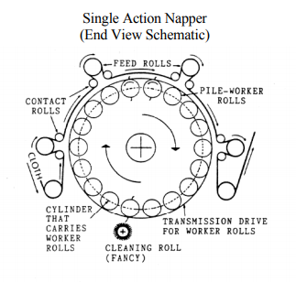
Double Action Napper
The most common type of napping machine throughout the textile industry is the double action napper. The main cylinder of the double action napper usually carries 24, 30, or 36 napper rolls, and rotates at a constant speed in the same direction as the flow of the fabric.
The double action machine has two sets of rollers termed pile and counter pile rollers, which rotates at the same speed and same direction; the points of the card wire are set in opposite direction to each other, and by adjusting speed of the two types of rollers, more or less raising effect can be produced.
Different napping results can be obtained by varying the speed of the napper rolls relative to the speed of the fabric.
A positive napping action occurs when the points of the napper wire travel at a speed greater than the speed of the fabric while greater counter pile energy produces a shorter, thicker nap.
When the napper roll wires travel at a speed slower than the speed of the fabric, a tucking or felting effect of the fabric pile occurs.
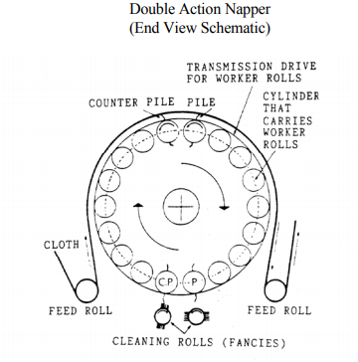
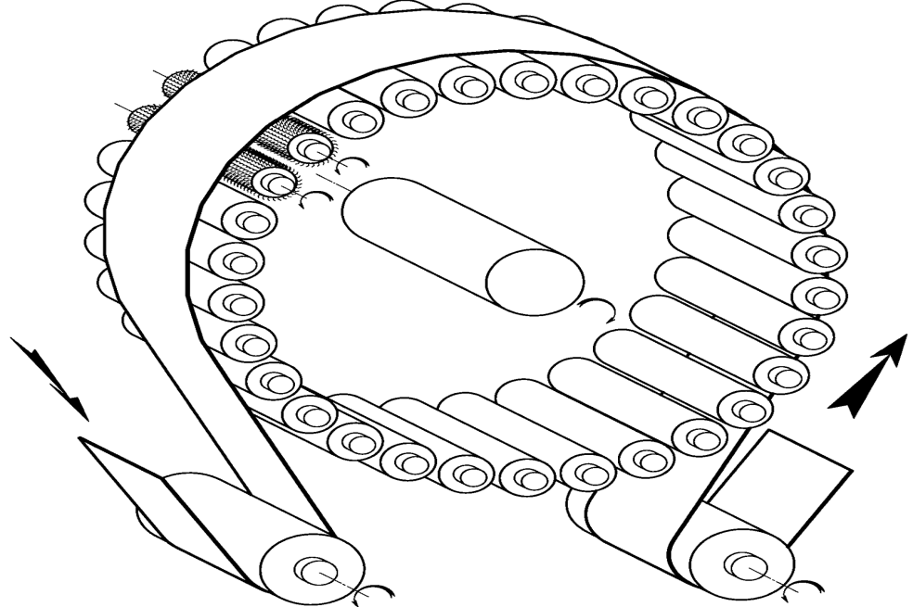

FULLING PROCESS
"Fulling“ is the process of increases the thickness and compactness of woven or knitted wool by subjecting it to moisture, heat, friction. When fulling is being done, the fibers continue to move (we call this migrate) and entangle on each other.
This process is applied on felt fabric from animal fiber, yarn that has already been woven or knitted.
FELTING
Felting is the process of turning a protein fiber (meaning animal fiber) such as sheep wool, alpaca, mohair, yak, etc. into a piece of fabric by connecting the individual fibers.
A felted fabric is created from fibres being compressed and matted, often pressed together using heat, moisture and a lot of pressure.
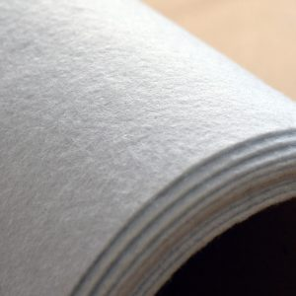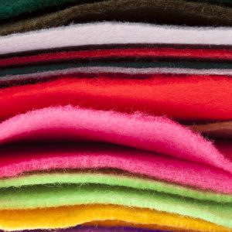
What is Felt Made From?
Felt is typically composed of wool or other natural raw materials, which generally produces the highest quality and softest fabric.
Wool also matts very easily, making it ideal for this fuzzy fabric. However, adding synthetic fibres into the mix (such as polyester or acrylic) can improve the product depending on its intended use.
Adding a synthetic fibres can increase felts durability for certain crafts or industrial use. It can also increase pliability.
A common fibre sometimes added to wool is rayon. Rayon removes the prickly feeling that pure wool can often have against the skin.
There are three main felting methods:
- Wet felting / Pressed:
This is the oldest form of felt .It even predates knitting and weaving techniques. It’s the most common type, which uses wool fibres or a blend of wool and synthetic fibres.
Those are compressed using heat and moisture, causing the fabrics to interlock. It can be cheap to make, and in a range of thicknesses which achieve a high density.
Hot water, sometimes with added soap, is sprayed onto layers of wool, while repeated agitation and compression causes the fibres of the wool to hook and weave together into a single piece of fabric.
Only certain types of fibre can be wet felted well. Most types of fleece, such as those taken from alpaca or sheep, can be put through the wet felting process.
Needled
In the case of needed felt, a blend of wool and synthetic fibres, or 100% wool, are interlocked. But this time by a machine rather than naturally.
Machines that contain thousands of needles interlock the fibres to produce this softer, less dense type of felt fabric. It is often used for crafts or cushioning.
Needle punching is a nonwoven process by which the fibres are mechanically entangled to produce a nonwoven fabric by repeated penetration of barbed needles through a preformed dry fibrous web.
The needle board is mounted on a beam which is given an up and down reciprocating motion.
As a result, the fibres are mechanically interlocked, thereby providing the mechanical strength.
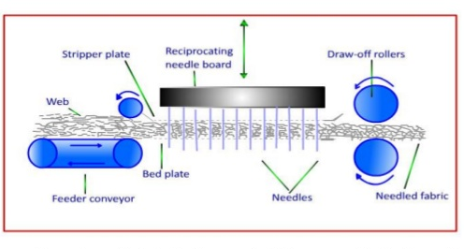
Woven
Wool or a wool blend is directly woven into a cloth and then moisture and pressure are applied.
This makes the fibres naturally interlock, as with pressed felt.
This durable fabric is ideal for musical instruments and door seals.
It has a much lower maximum thickness than needled or pressed felt.
Advantages & Disadvantages
Advantages
Durable
Warm but lightweight
Doesn’t fray
Easy to cut and work with
Available in wide range of colours and thicknesses
Generally inexpensive
Versatile
Disadvantages
Not particularly supple
Minimal elasticity
Coarse texture
Potential to shrink
Can pill or fuzz over time
"FULLING”
Fulling is the process of increases the thickness and compactness of woven or knitted wool by subjecting it to moisture, heat, friction.
Fulling can be done with the help of heat, moisture and extreme agitation to make a wool fabric shrink and therefore become stronger and warmer. When fulling is being done, the fibers continue to move (we call this migrate) and entangle on each other.
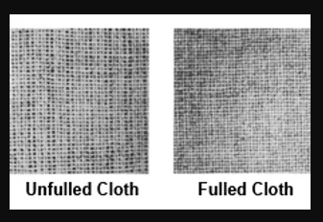
Fulling can be done in several ways. Here is an overview of the most common methods.
KNEADING/TOSSING
This is the most aggressive method of fulling. The textile will shrink very rapidly, but not necessarily evenly. It is more difficult to keep the cloth straight, with no bubbling or ruffled edges by this method alone.
Put the fabric on a waterproof surface. Pour on hot, soapy water and knead with your hands, much like you would knead bread. A variation of this is to roll up the fabric and knead the roll. Another variation is to bunch up the fabric and toss it down onto the table. The force of the fabric hitting the table helps the fibers to migrate.
Turn the folded cloth over and drop again. Repeat about 4 times. Refold, putting the creases into another area. Drop again. Continue until the felt seems to firm enough to be bunched up or kneaded as above.
Always check to make sure that the felt is not "hooking" onto itself. This can happen especially along the edges of the scarf.
RUBBING/WASHBOARDING
This is a great method for getting certain areas of the felted cloth to shrink in or for more controlled shrinkage than with tossing. In this method the entire cloth wont get full down evenly, this method is harder to control because wherever we are placing the pressure to rub the cloth will shrink more than the areas where there is not pressure.
Put the fabric onto the washboard and pour hot, soapy water on it. Rub areas of the fabric back and forth until they shrink and harden. A variation is to roll the fabric and rub the roll on the washboard.
Some people use other surfaces to rub on, such as rubber stair tread, a bamboo mat, etc. anything with a similar texture to a washboard. Glass washboards are preferable because it doesn't seem to make the felt pill as much as a metal one does.

ROLLING
This is the most control of all the fulling methods. However, it is the slowest method and puts a lot of strain on the arms and back. People often roll the felt for both the felting stage and the fulling stage. The textile starts off as loose fiber and after much rolling, ends up as a firm, tight felt.
Roll the fabric, usually with some sort of support cloth such as canvas, bamboo mats or bubble-wrap. Put ties around it and roll it back and forth with forearms, hands, feet, etc. Bamboo shades are preferable because its stiffness seems to make a more even felt.
CORONIZED
Coronizing is the process for heat setting, dyeing, and finishing glass fiber in one continuous operation . Since the flexibility of glass is low, the yarns resist bending around one another in the woven fabric.
Heat setting at a temperature of 1100f softens the yarns so that they bend and assume yarn crimp.
Coronized fabrics have greater wrinkle resistance and softer draping qualities.
After heat setting the glass fabric is treated with a lubricating oil before adding color and a water repellent finish using the Hycar – Quilon process.
Hycar is an acrylic latex resin with coloured pigment that is padded on the fabric and cured at a temperature of 320f . This is followed by treatment with Quilon , a water repellent substance, and the fabric is again cured.
The resin increase fiber flexibility. Screen printing and roller printing can be done by this process since the colour paste dries so quickly that one screen follows another.
EMBRODERY EFFECT:
Embroidery is the craft of decorating fabric or other materials using a needle to apply thread or yarn. Embroidery may also incorporate other materials such as pearls, beads, quills, and sequins. In modern days, embroidery is usually seen on caps, hats, coats, overlays, blankets, dress shirts, denim, dresses, stockings, and golf shirts. Embroidery is available with a wide variety of thread or yarn colour.
Machine embroidery is an embroidery process whereby a sewing machine or embroidery machine is used to create patterns on textiles. It is used commercially in product branding, corporate advertising, and uniform adornment. It is also used in the fashion industry to decorate garments and apparel. Machine embroidery is used by hobbyists and crafters to decorate gifts, clothing, and home decor. Examples include designs on quilts, pillows, and wall hangings.

TYPES OF MACHINE EMBROIDERY

Free-motion machine embroidery
In free-motion machine embroidery, embroidered designs are created by using a basic zigzag sewing machine. As this type of machine is used primarily for tailoring, it lacks the automated features of a specialized machine. The first zigzag sewing machine was patented by Helen Blanchard. To create free-motion machine embroidery, the embroiderer runs the machine and skillfully moves tightly hooped fabric under the needle to create a design. The "feed dogs" or machine teeth are lowered or covered, and the embroiderer moves the fabric manually. The embroiderer develops the embroidery manually, using the machine's settings for running stitch and fancier built-in stitches. A machine's zigzag stitch can create thicker lines within a design or be used to create a border. As this is a manual process rather than a digital reproduction, any pattern created using free-motion machine embroidery is unique and cannot be exactly reproduced, unlike with computerized embroidery.

Cornely hand-guided embroidery
This embroidery inherited the name of the Cornely machine. Created in the 19th century to imitate the Beauvais stitch (chain stitch), it is still used today, especially in the fashion industry. Cornely embroidery is a so-called hand-guided embroidery. The operator directs his machine according to the pattern. The fabric is moved by a crank located under the machine. The Cornely also has a universal drive system controlled by a handle. Some models can embroider sequins, cords, braids, etc. There are also Cornely machines performing a classic straight stitch.

Computerized machine embroidery]
Most modern embroidery machines are computer controlled and specifically engineered for embroidery. Industrial and commercial embroidery machines and combination sewing-embroidery machines have a hooping or framing system that holds the framed area of fabric taut under the sewing needle and moves it automatically to create a design from a pre-programmed digital embroidery pattern.

The computerized machine embroidery process
Machine embroidery is a multi-step process with many variables that impact the quality of the final product, including the type of fabric to be embellished, design size, stabilizer choice and type of thread utilized. The basic steps for creating embroidery with a computerized embroidery machine are as follows:
- Create an embroidery design file or purchase a stitchable machine embroidery file. Creation may take hours depending on the complexity of the design, and the software can be costly.
- Edit the design and/or combine with other designs.
- Export the design file to a (proprietary machine) embroidery file that mostly just contains commands for the embroidery machine. If you bought such a file, you may have to convert the file.
- Load the embroidery file into the embroidery machine, making sure it is the correct format for the machine and that the stitched design will fit in the appropriate hoop.
- Determine and mark the location of embroidery placement on the fabric to be embellished.
- Secure the fabric in a hoop with the appropriate stabilizer, and place it on the machine.
- Center the needle over the start point of the design.
- Start and monitor the embroidery machine, watching for errors and issues. Troubleshoot any problems as they arise. The operator should have plenty of needles, bobbins, a can of air (or small air compressor), a small brush, and scissors..
- Remove the completed design from machine. Separate the fabric from the hoop and trim the stabilizer, loose threads, etc.

